**KAUNO TECHNOLOGIJOS UNIVERSITETAS**

**INFORMATIKOS FAKULTETAS**

**Objektinis programavimas II (P175B123)**

***Darbų aplankas***

Atliko:

IFF-8/11 gr. studentas

Arnas Švenčionis

2019 m. vasario 20 d.

Priėmė:

Doc. Romas Marcinkevičius

**KAUNAS 2019**

**TURINYS**

Contents

1. Rekursija (L1) 4

1.1. Darbo užduotis 4

1.2. Grafinės vartotojo sąsajos schema 4

1.3. Sąsajoje panaudotų komponentų keičiamos savybės 4

1.4. Klasių diagrama 4

1.5. Programos vartotojo vadovas 5

1.6. Programos tekstas 5

1.7. Pradiniai duomenys ir rezultatai 9

1.8. Dėstytojo pastabos 10

2. Dinaminis atminties valdymas (L2) 11

2.1. Darbo užduotis 11

2.2. Grafinės vartotojo sąsajos schema 11

2.3. Sąsajoje panaudotų komponentų keičiamos savybės 12

2.4. Klasių diagrama 12

2.5. Programos vartotojo vadovas 14

2.6. Programos tekstas 14

2.7. Pradiniai duomenys ir rezultatai 28

2.8. Dėstytojo pastabos 34

3. Bendrinės klasės ir sąsajos (L3) 34

3.1. Darbo užduotis 34

3.2. Grafinės vartotojo sąsajos schema 34

3.3. Sąsajoje panaudotų komponentų keičiamos savybės 34

3.4. Klasių diagrama 35

3.5. Programos vartotojo vadovas 36

3.6. Programos tekstas 36

3.7. Pradiniai duomenys ir rezultatai 52

3.8. Dėstytojo pastabos 57

4. Kolekcijos ir išimčių valdymas (L4) 58

4.1. Darbo užduotis 58

4.2. Grafinės vartotojo sąsajos schema 58

4.3. Sąsajoje panaudotų komponentų keičiamos savybės 58

4.4. Klasių diagrama 59

4.5. Programos vartotojo vadovas 59

4.6. Programos tekstas 59

4.7. Pradiniai duomenys ir rezultatai 71

4.8. Dėstytojo pastabos 75

5. Deklaratyvusis programavimas (L5) 76

5.1. Darbo užduotis 76

5.2. Grafinės vartotojo sąsajos schema 76

5.3. Sąsajoje panaudotų komponentų keičiamos savybės 76

5.4. Klasių diagrama 77

5.5. Programos vartotojo vadovas 77

5.6. Programos tekstas 77

5.7 Pradiniai duomenys ir rezultatai 86

5.8 Dėstytojo pastabos 90

# Rekursija (L1)

## Darbo užduotis

**LD_3. Domino.**

Imami 7 vieno domino rinkinio kauliukai. Vieną domino kauliuką sudaro dvi dalys, kurių kiekvienoje arba nieko nėra (baltas), arba juodi taškai, kurių yra nuo 1 iki 6. Kauliuką galima nusakyti kaip dviženklį skaičių, kurio pirmas skaitmuo nurodo pirmos dalies taškų skaičių, o antrasis – antros. Jeigu dalis tuščia, tai rašomas skaitmuo 0 (nulis). Parašykite programą, kuri sudarytų iš šių 7 kauliukų visas galimas grandines, kai jungiami kauliukai galais su vienodu taškų skaičiumi. Gali būti, kad tokios grandinės visai nėra. Sudarant grandines, kauliukas gali būti apsukamas, t.y. kauliukas 35 gali būti padėtas, kaip 53. Kauliukų duomenys įvedami iš tekstinio failo‘Kur3.txt’. Čia vienoje eilutėje yra parašyti 7 (septyni) dviženkliai skaičiai. Rezultatus surašyti į tekstinį failą eilutėmis po vieną grandinę. Grandinę sudaro 7 kauliukai, tarp kiekvieno kauliuko (dviženklio skaičiaus) paliekamas vieno tarpo ženklas.

## Grafinės vartotojo sąsajos schema

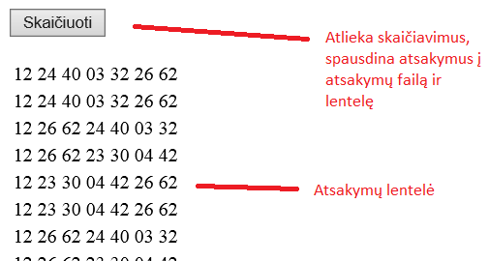

## Sąsajoje panaudotų komponentų keičiamos savybės

|  |  |  |
| --- | --- | --- |
| **Komponentas** | **Savybė** | **Reikšmė** |
| Button1 | Paspaudžiamas | Atlieka sprendimus, surašo atsakymus |
| Table1 | Saugo duomenis | Rodo atsakymus |
|  |  |  |

## Klasių diagrama

|  |
| --- |
| Konteineris |
| - kauliukai : string[]  - Count : integer |
| +Konteineris()  +Konteineris(in dydis : integer)  +PridetiKauliuka(in kauliukas : string)  +NustatytiKauliuka(in kauiukas : string, in ind : integer)  +GautiKauliuka{query}  +ApverstiKauliuka : string{query}  +Konteineris(in a : Konteineris, in index : integer) |

|  |
| --- |
| Forma1.aspx.cs |
| max : integer |
| #Page_Load {query}  #Button1_Click {query}  -Skaityti : Konteineris()  -Galimybes(in kauliukai : Konteineris, in rez : string)  -PrintTable{query}  -PrintToFile{query}  -Tikrinimas{query} |

## Programos vartotojo vadovas

Paspaudus mygtuką atliekami skaičiavimai – ieškomos visi įmanomi kauliukų išdėstymo variantai.

Variantai spausdinami lentele po mygtuku. Esant kauliukų trūkumui arba pertekliui, vartotojas informuojamas.

Jei nėra įmanomų kauliukų išdėstymo variantų, vartotojui pranešama.

## Programos tekstas

**Konteineris.cs**

using System;

using System.Collections.Generic;

using System.Linq;

using System.Web;

namespace _1Laboras

{

public class Konteineris

{

private string[] kauliukai;

public int Count { get; private set; }

/// <summary>

/// Sukuria nauja kauliuku konteineri 7 dydzio

/// </summary>

public Konteineris ()

{

kauliukai = new string[7];

Count = 0;

}

/// <summary>

/// sukuria nauja konteineri, dydi leidziama nustatyti

/// </summary>

/// <param name="dydis">konteinerio dydis</param>

public Konteineris (int dydis)

{

kauliukai = new string[dydis];

Count = 0;

}

/// <summary>

/// Prideti kauliuka i konteineri

/// </summary>

/// <param name="kauliukas">kauliukas</param>

public void PridetiKauliuka(string kauliukas)

{

kauliukai[Count++] = kauliukas;

}

/// <summary>

/// Nustatyti kauliuko duomenis

/// </summary>

/// <param name="kauliukas">naujas kauliukas</param>

/// <param name="ind">naujo kauliuko vieta konteineryje</param>

public void NustatytiKauliuka (string kauliukas, int ind)

{

kauliukai[ind] = kauliukas;

}

/// <summary>

/// Paima kauliuka is konteinerio

/// </summary>

/// <param name="ind">norimo kauliuko vieta konteineryje</param>

/// <returns>kauliuka</returns>

public string GautiKauliuka (int ind)

{

return kauliukai[ind];

}

public string ApverstiKauliuka (int index)

{

return kauliukai[index][1] + kauliukai[index][0].ToString();

}

/// <summary>

/// Sukuria nauja konteineri be nurodyto kauliuko

/// </summary>

/// <param name="a">paduotas konteineris</param>

/// <param name="index">nenorimas kauliukas</param>

public Konteineris(Konteineris a, int index)

{

int aa = 0;

kauliukai = new string[a.Count - 1];

for (int i = 0; i < a.Count; i++)

if (i != index) kauliukai[aa++] = a.GautiKauliuka(i);

Count = a.Count-1;

}

}

}

**Forma1.aspx**

<%@ Page Language="C#" AutoEventWireup="true" CodeBehind="Forma1.aspx.cs" Inherits="_1Laboras.Forma1" %>

<!DOCTYPE html>

<html xmlns="http://www.w3.org/1999/xhtml">

<head runat="server">

<title></title>

</head>

<body>

<form id="form1" runat="server">

<div>

<asp:Button ID="Button1" runat="server" OnClick="Button1_Click" Text="Skaičiuoti" />

<br />

<br />

<asp:Table ID="Table1" runat="server" Width="379px" style="margin-bottom: 0px">

</asp:Table>

</div>

</form>

</body>

</html>

**Forma1.aspx.cs**

using System;

using System.IO;

using System.Web.UI.WebControls;

namespace _1Laboras

{

public partial class Forma1 : System.Web.UI.Page

{

const int max = 7;

protected void Page_Load(object sender, EventArgs e)

{

}

protected void Button1_Click(object sender, EventArgs e)

{

File.Delete(Server.MapPath("Ats3.txt"));

Konteineris Kauliukai = Skaityti();

Galimybes(Kauliukai, "");

Tikrinimas();

}

/// <summary>

/// Nuskaito duomenis is tekstinio failo

/// </summary>

/// <returns>sukurta duomenu konteineri</returns>

Konteineris Skaityti()

{

Konteineris Kauliukai = new Konteineris();

string line = File.ReadAllText(Server.MapPath("App_Data/Kur3.txt"));

string[] values = line.Split(' ');

if(values.Length != max)

{

PrintTable("Netinkamas kauliukų skaičius");

PrintToFile("Netinkamas kauliukų skaičius");

return null;

}

for (int i = 0; i < max; i++)

Kauliukai.PridetiKauliuka(values[i]);

return Kauliukai;

}

/// <summary>

/// Skaiciuoja visas imanomas kauliuku sustatymo galimybes

/// </summary>

/// <param name="kauliukai">kauliuku rinkinys</param>

/// <param name="rez">rezultato eilute</param>

private void Galimybes (Konteineris kauliukai, string rez)

{

if (kauliukai == null)

return;

if (rez == "")

{

for (int i = 0; i < kauliukai.Count; i++)

{

Konteineris naujiKauliukai = new Konteineris(kauliukai, i);

rez = " " + kauliukai.GautiKauliuka(i);

Galimybes(naujiKauliukai, rez);

rez = " " + kauliukai.ApverstiKauliuka(i);

Galimybes(naujiKauliukai, rez);

}

}

else if(kauliukai.Count > 0)

{

for (int i = 0; i < kauliukai.Count; i++)

{

if(kauliukai.GautiKauliuka(i)[0] == rez[rez.Length - 1])

{

Konteineris naujiKauliukai = new Konteineris(kauliukai, i);

rez += " " + kauliukai.GautiKauliuka(i);

Galimybes(naujiKauliukai, rez);

rez = rez.Remove(rez.Length - 3, 3);

}

if(kauliukai.ApverstiKauliuka(i)[0] == rez[rez.Length - 1])

{

Konteineris naujiKauliukai = new Konteineris(kauliukai, i);

rez += " " + kauliukai.ApverstiKauliuka(i);

Galimybes(naujiKauliukai, rez);

rez = rez.Remove(rez.Length - 3, 3);

}

}

}

else

{

PrintTable(rez);

PrintToFile(rez);

}

}

/// <summary>

/// Atspausdina gautus atsakymus lentele

/// </summary>

/// <param name="rez">vienas atsakymas</param>

private void PrintTable (string rez)

{

TableCell cell = new TableCell();

cell.Text = rez;

TableRow row = new TableRow();

row.Cells.Add(cell);

Table1.Rows.Add(row);

}

/// <summary>

/// Spausdina gautus atsakymus i txt faila

/// </summary>

/// <param name="rez">vienas atsakymas</param>

private void PrintToFile (string rez)

{

using (StreamWriter writer = new StreamWriter(Server.MapPath(@"Ats3.txt"),

true))

{

writer.WriteLine("{0}", rez);

}

}

/// <summary>

/// Skaiciavimu gale patikrina kiek gauta atsakymu

/// Jei atsakymu negauta, pranesa

/// </summary>

private void Tikrinimas()

{

if (Table1.Rows.Count == 0)

{

PrintTable("Nėra galimų grandinių.");

PrintToFile("Nėra galimų grandinių.");

}

}

}

}

## Pradiniai duomenys ir rezultatai

**Pirmas bandymas:**

**Kur3.txt**

13 01 02 24 14 12 25

**Ats3.txt**

31 10 02 24 41 12 25

31 10 02 21 14 42 25

31 14 42 20 01 12 25

31 14 42 21 10 02 25

31 12 20 01 14 42 25

31 12 24 41 10 02 25

52 20 01 14 42 21 13

52 20 01 12 24 41 13

52 24 41 10 02 21 13

52 24 41 12 20 01 13

52 21 10 02 24 41 13

52 21 14 42 20 01 13

**Antras bandymas:**

**Kur3.txt**

13 26 54 15 65 21 42

**Ats3.txt**

Nėra galimų grandinių.

**Trečias bandymas:**

**Kur3.txt**

13 26 54 15 65 21

**Ats3.txt**

Netinkamas kauliukų skaičius

**Ketvirtas bandymas:**

**Kur3.txt**

12 24 26 40 03 32 62

**Ats3.txt**

12 24 40 03 32 26 62

12 24 40 03 32 26 62

12 26 62 24 40 03 32

12 26 62 23 30 04 42

12 23 30 04 42 26 62

12 23 30 04 42 26 62

12 26 62 24 40 03 32

12 26 62 23 30 04 42

24 40 03 32 26 62 21

24 40 03 32 26 62 21

26 62 24 40 03 32 21

26 62 23 30 04 42 21

23 30 04 42 26 62 21

23 30 04 42 26 62 21

26 62 24 40 03 32 21

26 62 23 30 04 42 21

## Dėstytojo pastabos

Testo rezultatas : 1;

# Dinaminis atminties valdymas (L2)

## Darbo užduotis

LD_3. Leidiniai.

Žmonės užsisako spaudą. Užsakymas vyksta metų ribose. Leidiniai gauna dėl to pajamas. Nustatykite kiekvienam mėnesiui, kurio leidinio pajamos yra didžiausios. Nustatykite bendrąsias leidinių pajamas. Sudarykite sąrašą leidinių, kurių pajamos mažesnės už vidutines. Duomenys:

Tekstiniame faile U3a.txt yra tokia informacija apie leidinius: leidinio kodas, leidinio pavadinimas, vieno mėnesio leidinio kaina.

Tekstiniame faile U3b.txt yra informacija apie prenumeratorius: prenumeratoriaus pavardė, adresas, laikotarpio pradžia (sveikasis skaičius 1..12), laikotarpio ilgis, leidinio kodas, leidinių kiekis.

Spausdinamas sąrašas turi būti surikiuotas pagal vieno mėnesio leidinio kainą mažėjimo ir leidinio pavadinimą abėcėlės tvarka. Sudarykite nurodyto leidinio (įvedamas klaviatūra) nurodyto mėnesio ((įvedamas klaviatūra) prenumeratorių sąrašą.

## Grafinės vartotojo sąsajos schema

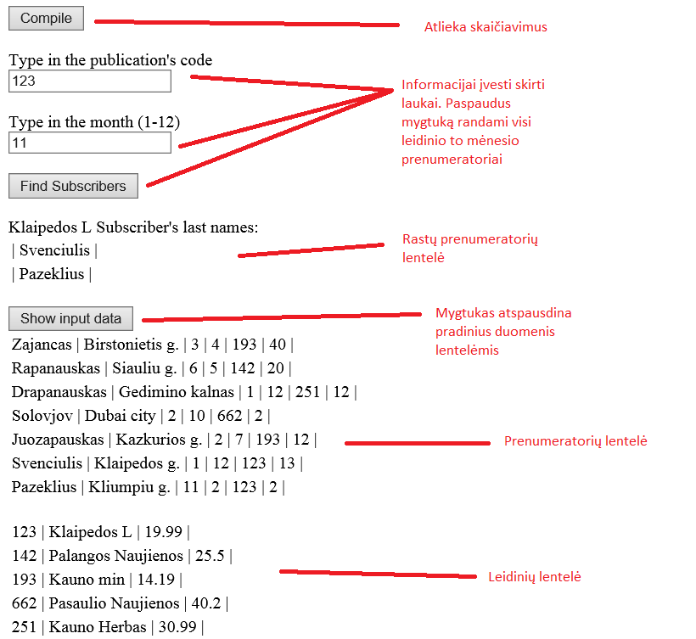

## Sąsajoje panaudotų komponentų keičiamos savybės

|  |  |  |
| --- | --- | --- |
| **Komponentas** | **Savybė** | **Reikšmė** |
| Button1 | Clickable | Atlieka skaičiavimus |
| Button2 | Clickable | Atspausdina prenumeratorių sarašą |
| Button3 | Clickable | Atspausdina pradinius duomenis lentele |
| Label1 | Rodyti tekstą | Yra virš TextBox1, paaiškina ką rašyti |
| Label2 | Rodyti tekstą | Yra virš TextBox2, paaiškina ką rašyti |
| Label3 | Rodyti tekstą | Yra virš Table1, paaiškina kas vaizduojama |
| SubTLabel | Rodyti tekstą | Pradinių prenumeratorių duomenų lentelė |
| SubPLabel | Rodyti tekstą | Pradinių leidinių duomenų lentelė |
| Label4 | Rodyti tekstą | Praneša vartotoją neradus duomenų |
| TextBox1 | Įvesti tekstą | Leidinio kodo įvedimui |
| TextBox2 | Įvesti tekstą | Mėnesio įvedimui |
| Table1 | Rodytiduomenis lentele | Spausdinamas leidinio prenumeratorių sąrašas |
| RequiredFieldValidator1 | Apsauga | Tikrina ar TextBox1 yra tuščias |
| RequiredFieldValidator2 | Apsauga | Tikrina ar TextBox2 yra tuščias |
| ValidationSummary1 | Praneša dėl apsaugos | Parodo jei bent vienas laukas yra tuščias |
| TableSubs | Rodytiduomenis lentele | Pradinių duomenų prenumeratoriu lentelė |
| TablePubs | Rodytiduomenis lentele | Pradinių duomenų leidinių lentelė |

## Klasių diagrama

|  |
| --- |
| Publication.cs |
| +Code : string  +Name : string  +Price: double |
| +Publication(in code: string, in name: string, in price: double)  +<(in l: Publication, in r: Publication): boolen  +>(in l: Publication, in r: Publication): boolen  +ToString() : string {query}  +Header() : string {query} |

|  |
| --- |
| Publist.cs |
| first : Knot  last : Knot  current : Knot |
| -Knot : sealed class  +PubList()  +AddToEnd(in pub : Publication)  +First()  +Next()  +End() : boolen  +PublicationData() : Publication  +Empty() : boolen  +SetIncomeToZero()  +Sorting() |

|  |
| --- |
| -Knot |
| +publication : Publication  +next : Knot |
| +Knot(in input : Publication, in adr : Knot) |

|  |
| --- |
| Subscriber.cs |
| +LastName : string  +Adress: string  +SubscribtionStart: integer  +SubscribtionDuration: integer  +SubscribtionCode: string  +SubscribtionAmount: integer |
| +Subscriber(in lastname: string in adress: string, in subscribtionStart: integer, in subscribtionDuration: integer, subscribtionCode: string, in subscribtionAmount: integer)  +ToString() : string  +Header() : string |

|  |
| --- |
| SubList.cs |
| first : Knot  last : Knot  current : Knot |
| -Knot : sealed class  +SubList()  +AddToEnd(in pub : Subscriber)  +First()  +Next()  +End() : boolen  +SubscriberData() : Subscriber  +Empty() : boolen |

|  |
| --- |
| -Knot |
| +subscriber : Subscriber  +next : Knot |
| +Knot(in input: Subscriber, in adr: Knot) |

|  |
| --- |
| Forma.aspx.cs |
| #Page_Load(in sender: object, in e : EventArgs)  #Button1_Click(in sender : object, in e : EventArgs)  -SubscriberInfo(in list: SubList) : SubList  -PublicationInfo(in list: PubList): PubList  -MostIncomeByMonth(in P: PubList, in S: SubList)  -HighestIncome(in list PubList) : Publication  - PrintBestMonthly(in pub: Publication, in month: integer)  -PublicationIncome(in Subs: Sublist, in Pubs: Publist)  -AllIncome(in Publications: Publist)  -LowIncomePublications(in All: PubList) : PubList  -Average(in All: PubList) : double  #Button2_Click(in sender: object, in e : EventArgs)  -FindPublicationWithCode(in list : PubList) : Publication  -FindSubscribers(in Subs: SubList, in Code : string, in month: integer): SubList  -PrintSubsribersToTable(in list: Sublist, in pubName: string)  -PrintData(in file: string, in list: SubList)  -PrintData(in file: string, in header: string, in list: PubList)  -PrintData(in file: string, in AllIncome: double)  -PrintSubsToTable(in subs: SubList)  -PrintPublicationToPubTable(in pubs: PubList)  -PrintInputData(in subs: SubList, in pubs: PubList, in answerFile: string)  #Button3_Click(in sender: object, in e : EventArgs)  -Checking(in Publications: PubList, in Subscribers: SubList) |

## Programos vartotojo vadovas

Paspaudus mygtuką Compile, programa atlieka skaičiavimus, atsakymus surašo į atsakymų faila.

Įrašius leidinio kodą ir norimą mėnesį į teksto laukus ir paspaudus mygtuką “Find Subscribers”, programa randa ir atspausdina to leidinio ir mėnesio prenumeratorių sarašą.

Paspaudus mygtuką “Show input data”, programa parodo pradinius duomenis lentelėmis.

## Programos tekstas

public class PubList

{

Knot first { get; set; }

Knot last { get; set; }

Knot current { get; set; }

private sealed class Knot

{

public Publication publication { get; set; }

public Knot next { get; set; }

public Knot(Publication input, Knot adr)

{

publication = input;

next = adr;

}

}

/// <summary>

/// sets the first and last pointers to null

/// </summary>

public PubList()

{

first = last = null;

}

/// <summary>

/// adds publication to the end of the list

/// </summary>

/// <param name="pub">Publication</param>

public void AddToEnd(Publication pub)

{

Knot temp = new Knot(pub, null);

if (first == null)

{

first = last = temp;

}

else

{

last.next = temp;

last = temp;

}

}

/// <summary>

/// sets the current pointer to the first

/// </summary>

public void First()

{

current = first;

}

/// <summary>

/// sets the current pointer to the next publication

/// </summary>

public void Next()

{

current = current.next;

}

/// <summary>

/// checks if the current pointer is the last one

/// </summary>

/// <returns>true or false</returns>

public bool End()

{

return current == null;

}

/// <summary>

/// gets the current publication's data

/// </summary>

/// <returns>pblication's data</returns>

public Publication PublicationData()

{

return current.publication;

}

/// <summary>

/// checks if the list is empty

/// </summary>

/// <returns>true or false</returns>

public bool Empty()

{

return first == null;

}

/// <summary>

/// sets all publication's incomes to zero

/// </summary>

public void SetIncomeToZero()

{

for (Knot i = first; i != null; i = i.next)

{

i.publication.Income = 0;

}

}

/// <summary>

/// sors the list

/// </summary>

public void Sorting()

{

bool bc = true;

Knot d0, d1, r1;

while (bc)

{

bc = false;

d0 = d1 = r1 = first;

while (d1 != null)

{

if(d0.publication > d1.publication)

{

bc = true;

if(d0 == first)

{

first = first.next;

d0.next = d1.next;

d1.next = d0;

}

else

{

d0.next = d1.next;

d1.next = d0;

r1.next = d1;

}

}

r1 = d0;

d0 = d1;

d1 = d1.next;

}

}

}

}

public class Publication

{

public string Code { get; set; }

public string Name { get; set; }

public double Price { get; set; }

public double Income { get; set; }

/// <summary>

/// creates a new publication object

/// </summary>

/// <param name="code"></param>

/// <param name="name"></param>

/// <param name="price"></param>

public Publication(string code, string name ,double price)

{

Code = code;

Name = name;

Price = price;

Income = 0;

}

/// <summary>

/// Operator. Compares by purice and name

/// </summary>

/// <param name="l">one pubication</param>

/// <param name="r">other publication</param>

/// <returns>true or false</returns>

static public bool operator < (Publication l, Publication r)

{

if (l.Price.CompareTo(r.Price) == 0)

{

return (l.Name.CompareTo(r.Name) < 0);

}

else return (l.Price.CompareTo(r.Price) < 0);

}

/// <summary>

/// > operator. Compares by price and name

/// </summary>

/// <param name="l">one publication</param>

/// <param name="r">other publication</param>

/// <returns>true or false</returns>

static public bool operator > (Publication l, Publication r)

{

if (l.Price.CompareTo(r.Price) == 0)

{

return (l.Name.CompareTo(r.Name) > 0);

}

else return (l.Price.CompareTo(r.Price) > 0);

}

/// <summary>

/// prinst all publication's data to one formated string

/// </summary>

/// <returns>formated publication's information</returns>

public override string ToString()

{

return String.Format("{0, 10} | {1, -20} | {2, 5} |", Code, Name, Price);

}

/// <summary>

/// prints formated header

/// </summary>

/// <returns>formated header string</returns>

public string Header()

{

return String.Format("{0, -10} | {1, -20} | {2, -5} |","Code", "Name", "Price");

}

}

public class SubList

{

Knot first { get; set; }

Knot last { get; set; }

Knot current { get; set; }

private sealed class Knot

{

public Subscriber subscriber { get; set; }

public Knot next { get; set; }

public Knot(Subscriber input, Knot adr)

{

subscriber = input;

next = adr;

}

}

/// <summary>

/// sets the first and last knots to null

/// </summary>

public SubList()

{

first = last = null;

}

/// <summary>

/// Adds a subscriber to the end of the list

/// </summary>

/// <param name="sub">subscriber data</param>

public void AddToEnd(Subscriber sub)

{

Knot temp = new Knot(sub, null);

if (first == null)

{

first = last = temp;

}

else

{

last.next = temp;

last = temp;

}

}

/// <summary>

/// sets the current pointer to the first

/// </summary>

public void First()

{

current = first;

}

/// <summary>

/// sets the current pointer to the next one

/// </summary>

public void Next()

{

current = current.next;

}

/// <summary>

/// checks of the current pointer is the last one

/// </summary>

/// <returns>true or false</returns>

public bool End()

{

return current == null;

}

/// <summary>

/// gets the current pointer's subscriber's data

/// </summary>

/// <returns></returns>

public Subscriber SubscriberData()

{

return current.subscriber;

}

/// <summary>

/// checks if the list is empty

/// </summary>

/// <returns>true or false</returns>

public bool Empty()

{

return first == null;

}

}

public class Subscriber

{

public string LastName { get; set; }

public string Adress { get; set; }

public int SubscribtionStart { get; set; }

public int SubscribtionDuration { get; set; }

public string SubscribtionCode { get; set; }

public int SubscribtionAmount { get; set; }

/// <summary>

/// creats a new subscriber object

/// </summary>

/// <param name="lastname">subscriber's last name</param>

/// <param name="adress">subscriber's adress</param>

/// <param name="subscribtionstart">subscriber's subscribtion start</param>

/// <param name="subscribtionduration">subscriber's subscribtion duration</param>

/// <param name="subscribtioncode">subscriber's subscribtion code</param>

/// <param name="subscribtionamount">subscriber's subscribtion amount</param>

public Subscriber (string lastname, string adress, int subscribtionstart, int subscribtionduration, string subscribtioncode, int subscribtionamount)

{

LastName = lastname;

Adress = adress;

SubscribtionStart = subscribtionstart;

SubscribtionDuration = subscribtionduration;

SubscribtionCode = subscribtioncode;

SubscribtionAmount = subscribtionamount;

}

/// <summary>

/// prints subscriber's information to one formated string

/// </summary>

/// <returns>formated information</returns>

public override string ToString()

{

return String.Format("{0, -20} | {1, -20} | {2, -20} | {3, -25} | {4, -25} | {5, - 20} |", LastName, Adress, SubscribtionStart, SubscribtionDuration, SubscribtionCode, SubscribtionAmount);

}

/// <summary>

/// prints the header of a table for a table of subscribers

/// </summary>

/// <returns>formated header</returns>

public string Header()

{

return String.Format("{0, -20} | {1, -20} | {2, 20} | {3, 25} | {4, 25} | {5, 20} |", "LastName", "Adress", "Subscribtion Start", "Subscribtion Duration", "Subscribtion Code", "Subscribtion Amount");

}

}

<%@ Page Language="C#" AutoEventWireup="true" CodeBehind="Forma.aspx.cs" Inherits="_2Lab.Forma" %>

<!DOCTYPE html>

<html xmlns="http://www.w3.org/1999/xhtml">

<head runat="server">

<title></title>

</head>

<body>

<form id="form1" runat="server">

<div>

<asp:Button ID="Button1" runat="server" OnClick="Button1_Click" Text="Compile" />

<asp:Label ID="Label4" runat="server" ForeColor="Red"></asp:Label>

<br />

<br />

<asp:Label ID="Label1" runat="server" Text="Type in the publication's code"></asp:Label>

<br />

<asp:TextBox ID="TextBox1" runat="server"></asp:TextBox>

<asp:RequiredFieldValidator ID="RequiredFieldValidator1" runat="server" ControlToValidate="TextBox1" ErrorMessage="Code required" ForeColor="Red" ValidationGroup="Val1">*</asp:RequiredFieldValidator>

<br />

<br />

<asp:Label ID="Label2" runat="server" Text="Type in the month (1-12)"></asp:Label>

<br />

<asp:TextBox ID="TextBox2" runat="server"></asp:TextBox>

<asp:RequiredFieldValidator ID="RequiredFieldValidator2" runat="server" ControlToValidate="TextBox2" ErrorMessage="Month required" ForeColor="Red" ValidationGroup="Val1">*</asp:RequiredFieldValidator>

<br />

<br />

<asp:Button ID="Button2" runat="server" OnClick="Button2_Click" Text="Find Subscribers" ValidationGroup="Val1" />

<br />

<br />

<asp:Label ID="Label3" runat="server" Visible="False"></asp:Label>

<br />

<asp:Table ID="Table1" runat="server" GridLines="Both">

</asp:Table>

<asp:ValidationSummary ID="ValidationSummary1" runat="server" ForeColor="Red" ValidationGroup="Val1" />

<br />

<asp:Button ID="Button3" runat="server" OnClick="Button3_Click" Text="Show input data" />

<br />

<asp:Label ID="SubTLabel" runat="server" Visible="False"></asp:Label>

<br />

<asp:Table ID="TableSubs" runat="server" Visible="False" GridLines="Both">

</asp:Table>

<br />

<asp:Label ID="PubTLabel" runat="server" Visible="False"></asp:Label>

<br />

<asp:Table ID="TablePubs" runat="server" Visible="False" GridLines="Both">

</asp:Table>

<br />

</div>

</form>

</body>

</html>

public partial class Forma : System.Web.UI.Page

{

protected void Page_Load(object sender, EventArgs e)

{

SubList Subscribers = new SubList();

PubList Publications = new PubList();

Publications = PublicationInfo(Publications);

Subscribers = SubscriberInfo(Subscribers);

PrintSPublicationToPubTable(Publications);

PrintSubsToSubTable(Subscribers);

Checking(Publications, Subscribers);

}

/// <summary>

/// Compiles the program

/// </summary>

/// <param name="sender"></param>

/// <param name="e"></param>

protected void Button1_Click(object sender, EventArgs e)

{

const string answerFile = "Answer.txt";

File.Delete(Server.MapPath(answerFile));

SubList Subscribers = new SubList();

PubList Publications = new PubList();

Publications = PublicationInfo(Publications);

Subscribers = SubscriberInfo(Subscribers);

MostIncomeByMonth(Publications, Subscribers);

PublicationIncome(Subscribers, Publications);

double AllPubIncome = AllIncome(Publications);

PrintData(answerFile, AllPubIncome);

PubList LowIncomePubs = LowIncomePublications(Publications);

LowIncomePubs.Sorting();

PrintDataToFile(answerFile, "Below average income publications:", LowIncomePubs);

PrintInputData(Subscribers, Publications, answerFile);

}

#region ReadData

/// <summary>

/// Reads subscriber information from file

/// and adds to the end of the list

/// </summary>

/// <param name="list">the list starting list</param>

/// <returns>a list of subscribers with their information</returns>

private SubList SubscriberInfo(SubList list)

{

using (StreamReader sr = new StreamReader(Server.MapPath("App_Data/U3b.txt")))

{

string line;

while ((line = sr.ReadLine()) != null)

{

string[] values = line.Split(';');

string lastName = values[0];

string city = values[1];

int beginning = int.Parse(values[2]);

int duration = int.Parse(values[3]);

string code = values[4];

int amount = int.Parse(values[5]);

Subscriber sub = new Subscriber(lastName, city, beginning, duration, code, amount);

list.AddToEnd(sub);

}

}

return list;

}

/// <summary>

/// Reads publication informations from file

/// and adds to the end of the given list

/// </summary>

/// <param name="list">a list that needs to be filled</param>

/// <returns>updated list</returns>

private PubList PublicationInfo(PubList list)

{

using (StreamReader sr = new StreamReader(Server.MapPath("App_Data/U3a.txt")))

{

string line;

while ((line = sr.ReadLine()) != null)

{

string[] values = line.Split(';');

string code = values[0];

string name = values[1];

double price = double.Parse(values[2]);

Publication publication = new Publication(code, name, price);

list.AddToEnd(publication);

}

}

return list;

}

#endregion

#region Income by month

/// <summary>

/// Goes month by month, publication by publication

/// and searches for it's subscribers and calculates

/// the month's income. makes a list of all publications

/// and their incomes each month

/// </summary>

/// <param name="P">list of publications</param>

/// <param name="S">list of subscribers</param>

private void MostIncomeByMonth(PubList P, SubList S)

{

for (int month = 1; month <= 12; month++)

{

PubList monthly = new PubList();

P.SetIncomeToZero();

for (P.First(); !P.End(); P.Next()) //eina per leidinius

{

for (S.First(); !S.End(); S.Next()) //eina per prenumeratorius

if (P.PublicationData().Code == S.SubscriberData().SubscribtionCode)

if ((month >= S.SubscriberData().SubscribtionStart) && (month <= S.SubscriberData().SubscribtionStart + S.SubscriberData().SubscribtionDuration - 1))

P.PublicationData().Income += S.SubscriberData().SubscribtionAmount * P.PublicationData().Price;

monthly.AddToEnd(P.PublicationData());

}

Publication maxPub = HighestIncome(monthly);

PrintBestMonthly(maxPub, month);

}

}

/// <summary>

/// Compares the publications

/// finds the publication with the most income

/// that month

/// </summary>

/// <param name="list">list of publications</param>

/// <returns>the publication with the highest income</returns>

private Publication HighestIncome(PubList list)

{

double max = 0;

Publication maxPub = null;

for (list.First(); !list.End(); list.Next())

if (list.PublicationData().Income > max)

{

max = list.PublicationData().Income;

maxPub = list.PublicationData();

}

return maxPub;

}

/// <summary>

/// Adds the publication with the highest income each month

/// to file

/// </summary>

/// <param name="pub"></param>

/// <param name="month"></param>

private void PrintBestMonthly(Publication pub, int month)

{

using (StreamWriter sw = new StreamWriter(Server.MapPath("Answer.txt"), true))

{

if (month == 1)

sw.WriteLine("Highest income every month:");

if (pub == null)

sw.WriteLine("{0, -2}. |{1, 20}|", month, "Nera");

else

sw.WriteLine("{0, -2}. |{1, 20}|", month, pub.Name);

}

}

#endregion

#region All Publication Income

/// <summary>

/// goes through all publications, finds their subscribers

/// and calculates the publication's info

/// </summary>

/// <param name="Subs">list of subscribers</param>

/// <param name="Publications">list of publications</param>

private void PublicationIncome(SubList Subs, PubList Publications)

{

Publications.SetIncomeToZero();

for (Publications.First(); !Publications.End(); Publications.Next())

for (Subs.First(); !Subs.End(); Subs.Next())

if (Subs.SubscriberData().SubscribtionCode == Publications.PublicationData().Code)

Publications.PublicationData().Income += Publications.PublicationData().Price * Subs.SubscriberData().SubscribtionAmount * Subs.SubscriberData().SubscribtionDuration;

}

/// <summary>

/// sums up all of the publication's income

/// </summary>

/// <param name="Publications">list of publications</param>

/// <returns>the sum of all publication's income</returns>

private double AllIncome(PubList Publications)

{

double sum = 0;

for (Publications.First(); !Publications.End(); Publications.Next())

sum += Publications.PublicationData().Income;

return sum;

}

#endregion

#region Low Income Publications

/// <summary>

/// goes through all publications and adds

/// the publications with below average income to a new list

/// </summary>

/// <param name="All">list of publications</param>

/// <returns>a list of publications with below average income</returns>

private PubList LowIncomePublications(PubList All)

{

double average = Average(All);

PubList LowIncomePubs = new PubList();

for (All.First(); !All.End(); All.Next())

if (All.PublicationData().Income < average)

LowIncomePubs.AddToEnd(All.PublicationData());

return LowIncomePubs;

}

/// <summary>

/// finds the average income of all publications

/// </summary>

/// <param name="All">list of publications</param>

/// <returns>the average income</returns>

private double Average(PubList All)

{

double sum = 0;

int k = 0;

for (All.First(); !All.End(); All.Next())

{

sum += All.PublicationData().Income;

k++;

}

return sum / k;

}

#endregion

#region Selected Publication and month

/// <summary>

/// the button used to find the subscribers of a selected

/// publication the selected month

/// </summary>

/// <param name="sender"></param>

/// <param name="e"></param>

protected void Button2_Click(object sender, EventArgs e)

{

PubList Pubs = new PubList();

Pubs = PublicationInfo(Pubs);

SubList Subs = new SubList();

Subs = SubscriberInfo(Subs);

string SelectedCode = TextBox1.Text;

int SelectedMonth = int.Parse(TextBox2.Text);

Publication foundPubl = FindPublicationWithCode(Pubs, SelectedCode);

SubList PubSubs = FindSubscribers(Subs, SelectedCode, SelectedMonth);

PrintSubscribersToTable(PubSubs, foundPubl);

}

/// <summary>

/// using the selected code, finds the publication

/// </summary>

/// <param name="list">list of publications</param>

/// <param name="code">the selected code</param>

/// <returns>the publication that was found using the code</returns>

private Publication FindPublicationWithCode(PubList list, string code)

{

for (list.First(); !list.End(); list.Next())

if (code == list.PublicationData().Code)

return list.PublicationData();

return null;

}

/// <summary>

/// finds the subscribers for the selected publication the selected month

/// </summary>

/// <param name="Subs">list o subscribers</param>

/// <param name="Code">the selected code</param>

/// <param name="month">the selected month</param>

/// <returns>a list of subscribers of the selected publication

/// the selected month</returns>

private SubList FindSubscribers(SubList Subs, string Code, int month)

{

SubList PubSubs = new SubList();

for (Subs.First(); !Subs.End(); Subs.Next())

if (Subs.SubscriberData().SubscribtionCode == Code)

if (month >= Subs.SubscriberData().SubscribtionStart && month <= Subs.SubscriberData().SubscribtionStart + Subs.SubscriberData().SubscribtionDuration - 1)

PubSubs.AddToEnd(Subs.SubscriberData());

return PubSubs;

}

/// <summary>

/// prints the found subscribers to a table

/// </summary>

/// <param name="list">list of subscribers</param>

/// <param name="pubName">the name of the publication</param>

private void PrintSubscribersToTable(SubList list, Publication pub)

{

if (!list.Empty() && pub != null)

for (list.First(); !list.End(); list.Next())

{

Label3.Visible = true;

Label3.Text = pub.Name + " Subscriber's last names:";

TableCell cell = new TableCell();

string tempstring = String.Format("{0}", list.SubscriberData().LastName);

cell.Text = tempstring;

TableRow row = new TableRow();

row.Cells.Add(cell);

Table1.Rows.Add(row);

}

else

{

Label3.Visible = true;

Label3.Text = "The publication does not have any subscribers the selected month.";

}

}

#endregion

#region PrintResults

/// <summary>

/// prints subscribers to a file

/// </summary>

/// <param name="file">file name</param>

/// <param name="list">list of subscribers</param>

private void PrintDataToFile(string file, SubList list)

{

using (StreamWriter sw = new StreamWriter(Server.MapPath(@file), true))

{

if(list.Empty())

{

sw.WriteLine("No subscribers found");

sw.WriteLine();

}

else

{

list.First();

string line = new string('-', list.SubscriberData().ToString().Length);

sw.WriteLine(list.SubscriberData().Header());

sw.WriteLine(line);

while (!list.End())

{

sw.WriteLine(list.SubscriberData().ToString());

sw.WriteLine(line);

list.Next();

}

sw.WriteLine();

}

}

}

/// <summary>

/// prints the given list to file

/// </summary>

/// <param name="file">file path</param>

/// <param name="header">header of the table</param>

/// <param name="list">list of publiactions</param>

private void PrintDataToFile(string file, string header, PubList list)

{

using (StreamWriter sw = new StreamWriter(Server.MapPath(@file), true))

{

if (list.Empty())

{

sw.WriteLine("No publications found");

sw.WriteLine();

}

else

{

list.First();

string line = new string('-', list.PublicationData().ToString().Length);

sw.WriteLine(header);

sw.WriteLine(line);

for (list.First(); !list.End(); list.Next())

{

sw.WriteLine(list.PublicationData().ToString());

sw.WriteLine(line);

}

sw.WriteLine();

}

}

}

/// <summary>

/// prints all income to file

/// </summary>

/// <param name="file">file path</param>

/// <param name="AllIncome">number</param>

private void PrintData(string file, double AllIncome)

{

using (StreamWriter sw = new StreamWriter(Server.MapPath(@file), true))

{

sw.WriteLine();

sw.WriteLine("All Publication income: {0:F2}", AllIncome);

sw.WriteLine();

}

}

/// <summary>

/// prints subscriber data to table in web

/// </summary>

/// <param name="list">list of subscribers</param>

private void PrintSubsToSubTable(SubList subs)

{

if (!subs.Empty())

{

SubTLabel.Text = "Input subscriber data:";

TableRow row = new TableRow();

TableCell[] cell = new TableCell[6];

for (int i = 0; i < 6; i++)

cell[i] = new TableCell();

cell[0].Text = "Last Name";

cell[1].Text = "Adress";

cell[2].Text = "Subscribtion start";

cell[3].Text = "Subscribtion duration";

cell[4].Text = "Subscribtion code";

cell[5].Text = "Subscribtion amount";

row.Cells.AddRange(cell);

TableSubs.Rows.Add(row);

for (subs.First(); !subs.End(); subs.Next())

{

row = new TableRow();

for (int i = 0; i < 6; i++)

cell[i] = new TableCell();

cell[0].Text = subs.SubscriberData().LastName;

cell[1].Text = subs.SubscriberData().Adress;

cell[2].Text = subs.SubscriberData().SubscribtionStart.ToString();

cell[3].Text = subs.SubscriberData().SubscribtionDuration.ToString();

cell[4].Text = subs.SubscriberData().SubscribtionCode;

cell[5].Text = subs.SubscriberData().SubscribtionAmount.ToString();

row.Cells.AddRange(cell);

TableSubs.Rows.Add(row);

}

}

else

{

SubTLabel.Text = "No Subscribers Found";

}

}

/// <summary>

/// prints publication data to web

/// </summary>

/// <param name="list">list of publiactions</param>

private void PrintSPublicationToPubTable(PubList pubs)

{

if (!pubs.Empty())

{

PubTLabel.Text = "Input publication data:";

TableRow row = new TableRow();

TableCell[] cell = new TableCell[3];

for (int i = 0; i < 3; i++)

cell[i] = new TableCell();

cell[0].Text = "Code";

cell[1].Text = "Name";

cell[2].Text = "Price";

row.Cells.AddRange(cell);

TablePubs.Rows.Add(row);

for (pubs.First(); !pubs.End(); pubs.Next())

{

row = new TableRow();

for (int i = 0; i < 3; i++)

cell[i] = new TableCell();

cell[0].Text = pubs.PublicationData().Code;

cell[1].Text = pubs.PublicationData().Name;

cell[2].Text = pubs.PublicationData().Price.ToString();

row.Cells.AddRange(cell);

TablePubs.Rows.Add(row);

}

}

else

{

PubTLabel.Text = "No Publications Found.";

}

}

/// <summary>

/// calls the prmethods

/// </summary>

/// <param name="subs">subscriber list</param>

/// <param name="pubs">publication list</param>

/// <param name="answerFile">asnwer file path</param>

private void PrintInputData(SubList subs, PubList pubs, string answerFile)

{

PrintDataToFile(answerFile, subs);

pubs.First();

PrintDataToFile(answerFile, pubs.PublicationData().Header(), pubs);

}

#endregion

#region Show Input Data

/// <summary>

/// 3rd button. Used to make the input tables visible

/// </summary>

/// <param name="sender"></param>

/// <param name="e"></param>

protected void Button3_Click(object sender, EventArgs e)

{

TableSubs.Visible = TablePubs.Visible = true;

SubTLabel.Visible = PubTLabel.Visible = true;

if (Button1.Enabled == false)

{

File.Delete(Server.MapPath("Answer.txt"));

SubList Subscribers = new SubList();

PubList Publications = new PubList();

Publications = PublicationInfo(Publications);

Subscribers = SubscriberInfo(Subscribers);

PrintDataToFile("Answer.txt", Subscribers);

PrintDataToFile("Answer.txt", "No publications found" ,Publications);

}

}

#endregion

#region Checking

/// <summary>

/// checks if the starting lists are empty

/// and if so, disables the buttons, alerts the user

/// </summary>

/// <param name="Publications">list of publications</param>

/// <param name="Subscribers">list of subscribers</param>

private void Checking(PubList Publications, SubList Subscribers)

{

if (Publications.Empty() || Subscribers.Empty())

{

Button1.Enabled = Button2.Enabled = false;

Label4.Text = "No Publications or Subscribers found!";

}

}

#endregion

}

## Pradiniai duomenys ir rezultatai

**Pirmas bandymas:**

**U3a.txt**

123;Klaipedos L;19.99

142;Palangos Naujienos;25.50

193;Kauno min;14.19

662;Pasaulio Naujienos;40.20

251;Kauno Herbas;30.99

**U3b.txt**

Zajancas;Birstonietis g.;3;4;193;40

Rapanauskas;Siauliu g.;6;5;142;20

Drapanauskas;Gedimino kalnas;1;12;251;12

Solovjov;Dubai city;2;10;662;2

Juozapauskas;Kazkurios g.;2;7;193;12

Svenciulis;Klaipedos g.;1;12;123;13

Pazeklius;Kliumpiu g.;11;2;123;2

**Answer.txt**

Highest income every month:

1 . | Kauno Herbas|

2 . | Kauno Herbas|

3 . | Kauno min|

4 . | Kauno min|

5 . | Kauno min|

6 . | Kauno min|

7 . | Palangos Naujienos|

8 . | Palangos Naujienos|

9 . | Palangos Naujienos|

10. | Palangos Naujienos|

11. | Kauno Herbas|

12. | Kauno Herbas|

All Publication income: 14477.32

Below average income publications:

-------------------------------------------

142 | Palangos Naujienos | 25.5 |

-------------------------------------------

662 | Pasaulio Naujienos | 40.2 |

-------------------------------------------

LastName | Adress | Subscribtion Start | Subscribtion Duration | Subscribtion Code | Subscribtion Amount |

---------------------------------------------------------------------------------------------------------------------------------------------------

Zajancas | Birstonietis g. | 3 | 4 | 193 | 40 |

---------------------------------------------------------------------------------------------------------------------------------------------------

Rapanauskas | Siauliu g. | 6 | 5 | 142 | 20 |

---------------------------------------------------------------------------------------------------------------------------------------------------

Drapanauskas | Gedimino kalnas | 1 | 12 | 251 | 12 |

---------------------------------------------------------------------------------------------------------------------------------------------------

Solovjov | Dubai city | 2 | 10 | 662 | 2 |

---------------------------------------------------------------------------------------------------------------------------------------------------

Juozapauskas | Kazkurios g. | 2 | 7 | 193 | 12 |

---------------------------------------------------------------------------------------------------------------------------------------------------

Svenciulis | Klaipedos g. | 1 | 12 | 123 | 13 |

---------------------------------------------------------------------------------------------------------------------------------------------------

Pazeklius | Kliumpiu g. | 11 | 2 | 123 | 2 |

---------------------------------------------------------------------------------------------------------------------------------------------------

Code | Name | Price |

-------------------------------------------

123 | Klaipedos L | 19.99 |

-------------------------------------------

142 | Palangos Naujienos | 25.5 |

-------------------------------------------

193 | Kauno min | 14.19 |

-------------------------------------------

662 | Pasaulio Naujienos | 40.2 |

-------------------------------------------

251 | Kauno Herbas | 30.99 |

-------------------------------------------

Į pirmą lauką įrašius 123, o į antrą 11, atspausdinama ši lentelė:

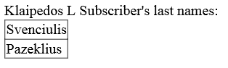

Pradiniai duomenys vartotojo sąsajoje:

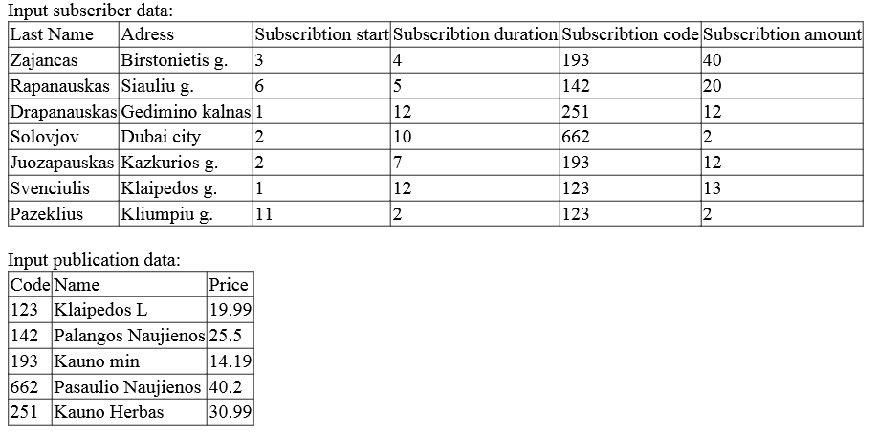

Į pirmą lauką įrašius 142, o 5 antrą - 2, spausdinamas rezultatas yra:

The publication does not have any subscribers the selected month.

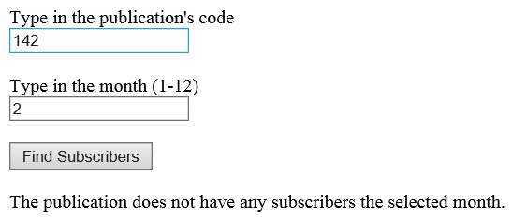

Įrašius 75a ir 2, rezultatas gaunamas toks pat:

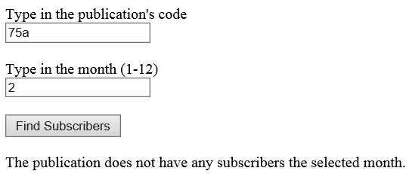

**Antras bandymas:**

**U3a.txt - tuščias;**

**U3b.txt**

Zajancas;Birstonietis g.;3;4;193;40

Rapanauskas;Siauliu g.;6;5;142;20

Drapanauskas;Gedimino kalnas;1;12;251;12

Pazeklius;Kliumpiu g.;11;2;123;2

Pasaulius;Jorko g.;5;5;76G;31

**Answer.txt**

LastName | Adress | Subscribtion Start | Subscribtion Duration | Subscribtion Code | Subscribtion Amount |

---------------------------------------------------------------------------------------------------------------------------------------------------

Zajancas | Birstonietis g. | 3 | 4 | 193 | 40 |

---------------------------------------------------------------------------------------------------------------------------------------------------

Rapanauskas | Siauliu g. | 6 | 5 | 142 | 20 |

---------------------------------------------------------------------------------------------------------------------------------------------------

Drapanauskas | Gedimino kalnas | 1 | 12 | 251 | 12 |

---------------------------------------------------------------------------------------------------------------------------------------------------

Pazeklius | Kliumpiu g. | 11 | 2 | 123 | 2 |

---------------------------------------------------------------------------------------------------------------------------------------------------

Pasaulius | Jorko g. | 5 | 5 | 76G | 31 |

---------------------------------------------------------------------------------------------------------------------------------------------------

No publications found

**Vartotojo sąsaja:**

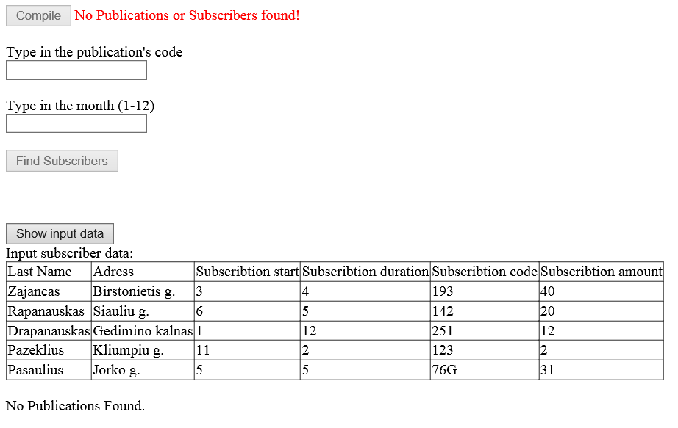

**Trečias bandymas:**

**U3a.txt**

123;Klaipedos L;19.99

142;Palangos Naujienos;25.50

193;Kauno min;14.19

662;Pasaulio Naujienos;40.20

251;Kauno Herbas;30.99

**U3b.txt**

Kudlius;Birstonietis g.;3;4;193;40

Picas;Siauliu g.;6;5;142;20

Drapanauskas;Gedimino kalnas;1;10;142;12

Pazeklius;Kliumpiu g.;11;2;123;2

Pasaulius;Jorko g.;5;5;76G;31

Svarainis;Daukanto g.;4;10;142;31

Jonevicius;Paluonio g.;1;1;251;15

**Answer.txt**

Highest income every month:

1 . | Kauno Herbas|

2 . | Palangos Naujienos|

3 . | Kauno min|

4 . | Palangos Naujienos|

5 . | Palangos Naujienos|

6 . | Palangos Naujienos|

7 . | Palangos Naujienos|

8 . | Palangos Naujienos|

9 . | Palangos Naujienos|

10. | Palangos Naujienos|

11. | Palangos Naujienos|

12. | Palangos Naujienos|

All Publication income: 16330.21

Below average income publications:

-------------------------------------------

193 | Kauno min | 14.19 |

-------------------------------------------

123 | Klaipedos L | 19.99 |

-------------------------------------------

251 | Kauno Herbas | 30.99 |

-------------------------------------------

662 | Pasaulio Naujienos | 40.2 |

-------------------------------------------

LastName | Adress | Subscribtion Start | Subscribtion Duration | Subscribtion Code | Subscribtion Amount |

---------------------------------------------------------------------------------------------------------------------------------------------------

Kudlius | Birstonietis g. | 3 | 4 | 193 | 40 |

---------------------------------------------------------------------------------------------------------------------------------------------------

Picas | Siauliu g. | 6 | 5 | 142 | 20 |

---------------------------------------------------------------------------------------------------------------------------------------------------

Drapanauskas | Gedimino kalnas | 1 | 10 | 142 | 12 |

---------------------------------------------------------------------------------------------------------------------------------------------------

Pazeklius | Kliumpiu g. | 11 | 2 | 123 | 2 |

---------------------------------------------------------------------------------------------------------------------------------------------------

Pasaulius | Jorko g. | 5 | 5 | 76G | 31 |

---------------------------------------------------------------------------------------------------------------------------------------------------

Svarainis | Daukanto g. | 4 | 10 | 142 | 31 |

---------------------------------------------------------------------------------------------------------------------------------------------------

Jonevicius | Paluonio g. | 1 | 1 | 251 | 15 |

---------------------------------------------------------------------------------------------------------------------------------------------------

Code | Name | Price |

-------------------------------------------

123 | Klaipedos L | 19.99 |

-------------------------------------------

142 | Palangos Naujienos | 25.5 |

-------------------------------------------

193 | Kauno min | 14.19 |

-------------------------------------------

662 | Pasaulio Naujienos | 40.2 |

-------------------------------------------

251 | Kauno Herbas | 30.99 |

-------------------------------------------

Įvedus 142 į pirmą laukelį ir 6 į antrą, gaunamas toks atsakymas:

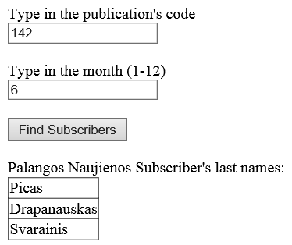

**Pradiniai duomenys lentele:**

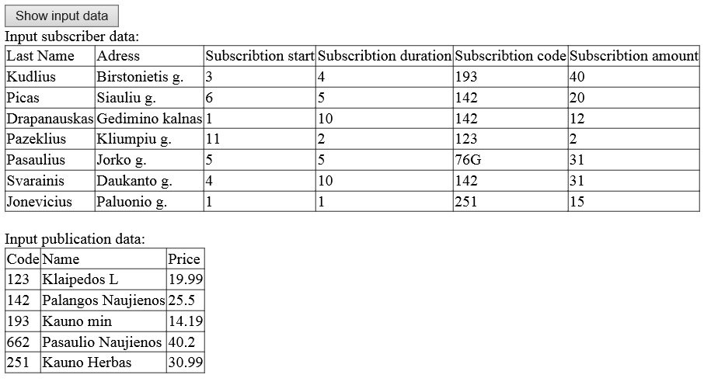

## Dėstytojo pastabos

Testo rezultatas: 1

# Bendrinės klasės ir sąsajos (L3)

## Darbo užduotis

LD_3. Leidiniai.

Žmonės užsisako spaudą. Užsakymas vyksta metų ribose. Leidiniai gauna dėl to pajamas. Nustatykite kiekvienam mėnesiui, kurio leidinio pajamos yra didžiausios. Nustatykite bendrąsias leidinių pajamas. Sudarykite sąrašą leidinių, kurių pajamos mažesnės už vidutines. Duomenys:

Tekstiniame faile U3a.txt yra tokia informacija apie leidinius: leidinio kodas, leidinio pavadinimas, vieno mėnesio leidinio kaina.

Tekstiniame faile U3b.txt yra informacija apie prenumeratorius: prenumeratoriaus pavardė, adresas, laikotarpio pradžia (sveikasis skaičius 1..12), laikotarpio ilgis, leidinio kodas, leidinių kiekis.

Spausdinamas sąrašas turi būti surikiuotas pagal vieno mėnesio leidinio kainą mažėjimo ir leidinio pavadinimą abėcėlės tvarka. Sudarykite nurodyto leidinio (įvedamas klaviatūra) nurodyto mėnesio ((įvedamas klaviatūra) prenumeratorių sąrašą.

## Grafinės vartotojo sąsajos schema

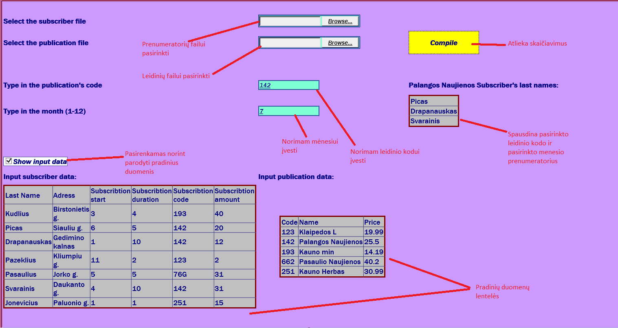

## Sąsajoje panaudotų komponentų keičiamos savybės

|  |  |  |
| --- | --- | --- |
| **Komponentas** | **Savybė** | **Reikšmė** |
| Button1 | Clickable | Atlieka skaičiavimus |
| Label1 | Rodyti tekstą | Yra prieTextBox1, paaiškina ką rašyti |
| Label2 | Rodyti tekstą | Yra prieTextBox2, paaiškina ką rašyti |
| Label3 | Rodyti tekstą | Yra virš Table1, paaiškina kas vaizduojama |
| SubTLabel | Rodyti tekstą | Pradinių prenumeratorių duomenų lentelė |
| SubPLabel | Rodyti tekstą | Pradinių leidinių duomenų lentelė |
| Label4 | Rodyti tekstą | Praneša vartotoją neradus duomenų |
| TextBox1 | Įvesti tekstą | Leidinio kodo įvedimui |
| TextBox2 | Įvesti tekstą | Mėnesio įvedimui |
| Table1 | Rodytiduomenis lentele | Spausdinamas leidinio prenumeratorių sąrašas |
| TableSubs | Rodytiduomenis lentele | Pradinių duomenų prenumeratoriu lentelė |
| TablePubs | Rodytiduomenis lentele | Pradinių duomenų leidinių lentelė |
| CheckBox1 | Pasirinkti | Pasirenkamas norint rodyti pradinius duomenis lentelėmis |
| FileUpload1 | Ikeliamas failas | Naudojamas prenumeratoriu failui pasirinkti |
| FileUpload2 | Ikeliamas failas | Naudojamas leidiniu failui pasirinkti |

## Klasių diagrama

|  |
| --- |
| Subscriber |
| +LastName : string  +Adress : string  +SubscribtionStart : integer  +SubscribtionDuration : integer  +SubscribtionCode : string  +SubscribtionAmount : integer  +Subscriber(in lastname :string, in adress :string, in subscribtionstart :integer, in subscribtionduration :integer, in subscribtioncode :string, in subscribtionamount :integer)  +ToString() : string  +Header() : string  +CompareTo(in other :Subscriber) : integer  +Equals(in other :Subscriber) : boolean |

|  |
| --- |
| Publication |
| +Code : string  +Name : string  +Price : float  +Income : float  +Publication(in code :string, in name :string, in price :float)  +CompareTo(in other :Publication) : integer  +Equals(in other :Publication) : boolean  +ToString() : string  +Header() : string |

|  |
| --- |
| KnotList |
| -first : Knot<type>  -last : Knot<type>  -current : Knot<type>  +KnotList()  +GetData() : type  +AddToEnd(in newObject :type)  +First()  +Next()  +Previous()  +End() : boolean  +Empty() : boolean  +Sorting()  +GetEnumerator() : IEnumerator<type> |

|  |
| --- |
| Knot<type> |
| +data : type  +next : Knot<type>  +previous : Knot<type>  +Knot(in input :type, in adrN :Knot<type>, in adrP :Knot<type>) |

|  |
| --- |
| Forma.apsx |
| #Page_Load(in sender :object, in e :EventArgs)  #Button1_Click(in sender :object, in e :EventArgs)  -SubscriberInfo(in list :KnotList<Subscriber>, in File :Stream)  -PublicationInfo(in list :KnotList<Publication>, in File :Stream)  -MostIncomeByMonth(in P :KnotList<Publication>, in S :KnotList<Subscriber>)  -HighestIncome(in list :KnotList<Publication>) : Publication  -PrintBestMonthly(in pub :Publication, in month :integer)  -PublicationIncome(in Subs :KnotList<Subscriber>, in Publications :KnotList<Publication>)  -AllIncome(in Publications :KnotList<Publication>) : float  -LowIncomePublications(in All :KnotList<Publication>) : KnotList<Publication>  -Average(in All :KnotList<Publication>) : float  -SetIncomeToZero(in list :KnotList<Publication>)  -FindSelectedPubSubs(in Pubs :KnotList<Publication>, in Subs :KnotList<Subscriber>)  -FindPublicationWithCode(in list :KnotList<Publication>, in code :string) : Publication  -FindSubscribers(in Subs :KnotList<Subscriber>, in Code :string, in month :integer) : KnotList<Subscriber>  -PrintSubscribersToTable(in list :KnotList<Subscriber>, in pub :Publication)  -Print<type>(in file :string, in tableName :string, in tableHeader :string, in list :IEnumerable<type>)  -PrintData(in file :string, in AllIncome :float)  -PrintSubsToSubTable(in subs :KnotList<Subscriber>)  -PrintSPublicationToPubTable(in pubs :KnotList<Publication>)  -PrintInputData(in subs :KnotList<Subscriber>, in pubs :KnotList<Publication>, in answerFile :string)  -Checking(in Publications :KnotList<Publication>, in Subscribers :KnotList<Subscriber>) : boolean |

## Programos vartotojo vadovas

Pasirinkus prenumeratorių ir leidinių failus ir paspaudus Compile mygtuką, yra atliekami skaičiavimai. Norint rasti norimo leidinio prenumeratorių sąrašą norimą mėnesį, juos galima rasti pasinaudojus TextBox1 ir TextBox2. Bus spausdinama prenumeratorių lentelė. Pasirinkus Show Input Data check box, kitą kartą paspaudus kompiliavimo mygtuką, bus rodomi pradiniai duomenys

## Programos tekstas

**Publication.cs**

public class Publication : IComparable<Publication>, IEquatable<Publication>

{

public string Code { get; set; }

public string Name { get; set; }

public double Price { get; set; }

public double Income { get; set; }

/// <summary>

/// creates a new publication object

/// </summary>

/// <param name="code"></param>

/// <param name="name"></param>

/// <param name="price"></param>

public Publication(string code, string name ,double price)

{

Code = code;

Name = name;

Price = price;

Income = 0;

}

public int CompareTo(Publication other)

{

if (other == null)

return 1;

if (Price.CompareTo(other.Price) == 0)

{

return (Name.CompareTo(other.Name));

}

else return (Price.CompareTo(other.Price));

}

public bool Equals(Publication other)

{

if (other == null)

return false;

if (this.Name == other.Name && this.Code == other.Code)

return true;

else

return false;

}

/// <summary>

/// prinst all publication's data to one formated string

/// </summary>

/// <returns>formated publication's information</returns>

public override string ToString()

{

return String.Format("{0, 10} | {1, -20} | {2, 5} |", Code, Name, Price);

}

/// <summary>

/// prints formated header

/// </summary>

/// <returns>formated header string</returns>

public string Header()

{

return String.Format("{0, -10} | {1, -20} | {2, -5} |","Code", "Name", "Price");

}

}

**Subscriber.cs**

public class Subscriber : IComparable<Subscriber>, IEquatable<Subscriber>

{

public string LastName { get; set; }

public string Adress { get; set; }

public int SubscribtionStart { get; set; }

public int SubscribtionDuration { get; set; }

public string SubscribtionCode { get; set; }

public int SubscribtionAmount { get; set; }

/// <summary>

/// creats a new subscriber object

/// </summary>

/// <param name="lastname">subscriber's last name</param>

/// <param name="adress">subscriber's adress</param>

/// <param name="subscribtionstart">subscriber's subscribtion start</param>

/// <param name="subscribtionduration">subscriber's subscribtion duration</param>

/// <param name="subscribtioncode">subscriber's subscribtion code</param>

/// <param name="subscribtionamount">subscriber's subscribtion amount</param>

public Subscriber (string lastname, string adress, int subscribtionstart, int subscribtionduration, string subscribtioncode, int subscribtionamount)

{

LastName = lastname;

Adress = adress;

SubscribtionStart = subscribtionstart;

SubscribtionDuration = subscribtionduration;

SubscribtionCode = subscribtioncode;

SubscribtionAmount = subscribtionamount;

}

/// <summary>

/// prints subscriber's information to one formated string

/// </summary>

/// <returns>formated information</returns>

public override string ToString()

{

return String.Format("{0, -20} | {1, -20} | {2, -20} | {3, -25} | {4, -25} | {5, - 20} |", LastName, Adress, SubscribtionStart, SubscribtionDuration, SubscribtionCode, SubscribtionAmount);

}

/// <summary>

/// prints the header of a table for a table of subscribers

/// </summary>

/// <returns>formated header</returns>

public string Header()

{

return String.Format("{0, -20} | {1, -20} | {2, 20} | {3, 25} | {4, 25} | {5, 20} |", "LastName", "Adress", "Subscribtion Start", "Subscribtion Duration", "Subscribtion Code", "Subscribtion Amount");

}

public int CompareTo(Subscriber other)

{

if (other == null)

return 1;

if (LastName.CompareTo(other.LastName) == 0)

{

return (Adress.CompareTo(other.Adress));

}

else return (LastName.CompareTo(other.LastName));

}

public bool Equals(Subscriber other)

{

if (other == null)

return false;

if (this.LastName == other.LastName && this.Adress == other.Adress)

return true;

else

return false;

}

}

**KnotList.cs**

using System;

using System.Collections.Generic;

using System.Linq;

using System.Web;

using System.Collections;

namespace _2Lab

{

public class KnotList<type> : IEnumerable<type>

where type : IComparable<type>, IEquatable<type>

{

private Knot<type> first;

private Knot<type> last;

private Knot<type> current;

private sealed class Knot<type>

{

public type data { get; set; }

public Knot<type> next { get; set; }

public Knot<type> previous { get; set; }

/// <summary>

/// creates a new knot

/// </summary>

/// <param name="input">input data</param>

/// <param name="adrN">previous knot</param>

/// <param name="adrP">next knot</param>

public Knot(type input, Knot<type> adrN, Knot<type> adrP)

{

data = input;

previous = adrN;

next = adrP;

}

}

/// <summary>

/// sets the first and last knots to null

/// </summary>

public KnotList()

{

this.first = this.last = current = null;

}

/// <summary>

/// gets the current pointer's object's data

/// </summary>

/// <returns></returns>

public type GetData()

{

return current.data;

}

/// <summary>

/// Adds a object to the end of the list

/// </summary>

/// <param name="sub">subscriber data</param>

public void AddToEnd(type newObject)

{

Knot<type> temp = new Knot<type>(newObject, last, null);

if (first != null)

last.next = temp;

else

first = temp;

last = temp;

}

/// <summary>

/// sets the current pointer to the first

/// </summary>

public void First()

{

current = first;

}

/// <summary>

/// sets the current pointer to the next one

/// </summary>

public void Next()

{

current = current.next;

}

/// <summary>

/// sets the current pointer to the previous one

/// </summary>

public void Previous()

{

current = current.previous;

}

/// <summary>

/// checks of the current pointer is the last one

/// </summary>

/// <returns>true or false</returns>

public bool End()

{

return current == null;

}

/// <summary>

/// checks if the list is empty

/// </summary>

/// <returns>true or false</returns>

public bool Empty()

{

return first == null;

}

/// <summary>

/// sors the list

/// </summary>

public void Sorting()

{

for (Knot<type> n = first; n != null; n = n.next)

{

Knot<type> maxv = n;

for (Knot<type> n2 = n; n2 != null; n2 = n2.next)

if (n2.data.CompareTo(maxv.data) < 0)

maxv = n2;

type St = n.data;

n.data = maxv.data;

maxv.data = St;

}

}

/// <summary>

/// goes through list, saves last exit

/// </summary>

/// <returns>current one's data</returns>

public IEnumerator<type> GetEnumerator()

{

for (Knot<type> dd = first; dd != null; dd = dd.next)

{

yield return dd.data;

}

}

IEnumerator IEnumerable.GetEnumerator()

{

throw new NotImplementedException();

}

}

}

**Forma.aspx**

<%@ Page Language="C#" AutoEventWireup="true" CodeBehind="Forma.aspx.cs" Inherits="_2Lab.Forma" %>

<!DOCTYPE html>

<html xmlns="http://www.w3.org/1999/xhtml">

<head runat="server">

<title></title>

<style>

.TextBoxStyle{

border-style: double;

background-color: aquamarine;

font-style: italic;

text-shadow: initial;

font-family: "franklin Gothic Medium", "Arial Narrow", Arial, sans-serif;

color: #000080;

text-decoration: underline;

cursor: text;

}

.auto-style1 {

width: 100%;

}

.auto-style2 {

width: 288px;

}

.auto-style3 {

width: 288px;

height: 34px;

}

.auto-style4 {

height: 34px;

}

.auto-style5 {

width: 317px;

}

.auto-style6 {

height: 34px;

width: 317px;

}

.auto-style7 {

width: 288px;

height: 26px;

}

.auto-style8 {

width: 317px;

height: 26px;

}

.auto-style9 {

height: 26px;

}

.auto-style10 {

width: 288px;

height: 33px;

}

.auto-style11 {

width: 317px;

height: 33px;

}

.auto-style12 {

height: 33px;

}

.ButtonStyle {

font-family: "Franklin Gothic Medium", "Arial Narrow", Arial, sans-serif;

font-weight: bold;

font-style: oblique;

font-variant: normal;

text-transform: none;

color: #000080;

background-color: #FFFF00;

padding: 0px;

border: thin dashed #000080;

font-size: inherit;

cursor: pointer;

}

.LabelStyle {

font-family: "Franklin Gothic Medium", "Arial Narrow", Arial, sans-serif;

color: #000080;

font-weight: bold;

}

.TableStyle {

font-family: "Franklin Gothic Medium", "Arial Narrow", Arial, sans-serif;

color: #000080;

table-layout: fixed;

border-collapse: collapse;

border-spacing: 10px;

border: 3px solid #800000;

background-color: #C0C0C0;

}

.CheckBoxStyle {

font-family: "Franklin Gothic Medium", "Arial Narrow", Arial, sans-serif;

font-size: medium;

font-style: oblique;

font-weight: bolder;

color: #000080;

background-color: #FFFFFF;

border-style: groove;

border-width: thin;

cursor: pointer;

}

.BackgroundStyle {

background-color: #CC99FF;

border: thick double #800000;

}

.IndividualCellColor {

background-color: #9900CC;

}

</style>

</head>

<body>

<form id="form1" runat="server">

<div class="BackgroundStyle">

<table class="auto-style1">

<tr>

<td class="auto-style2">&nbsp;</td>

<td class="auto-style5">

&nbsp;</td>

<td>&nbsp;</td>

</tr>

<tr>

<td class="auto-style3">

<asp:Label ID="Label5" runat="server" Text="Select the subscriber file" CssClass="LabelStyle"></asp:Label>

</td>

<td class="auto-style6">

<asp:FileUpload ID="FileUpload1" runat="server" CssClass="TextBoxStyle" />

<asp:CustomValidator ID="CustomValidator1" runat="server" ControlToValidate="FileUpload1" ErrorMessage="*" ForeColor="Red" ValidationGroup="Val 2"></asp:CustomValidator>

</td>

<td class="auto-style4">

<asp:Label ID="Label4" runat="server" ForeColor="Red" Visible="False" Font- Bold="True">No list found</asp:Label>

</td>

</tr>

<tr>

<td class="auto-style2">

<asp:Label ID="Label6" runat="server" Text="Select the publication file" CssClass="LabelStyle"></asp:Label>

</td>

<td class="auto-style5">

<asp:FileUpload ID="FileUpload2" runat="server" CssClass="TextBoxStyle" />

<asp:CustomValidator ID="CustomValidator2" runat="server" ControlToValidate="FileUpload2" ErrorMessage="*" ForeColor="Red" ValidationGroup="Val 2"></asp:CustomValidator>

</td>

<td>

<asp:Button ID="Button1" runat="server" OnClick="Button1_Click" Text="Compile" ValidationGroup="Val 2" CssClass="ButtonStyle" Height="50px" Width="150px" />

</td>

</tr>

<tr>

<td class="auto-style2">&nbsp;</td>

<td class="auto-style5">&nbsp;</td>

<td>&nbsp;</td>

</tr>

<tr>

<td class="auto-style2">&nbsp;</td>

<td class="auto-style5">&nbsp;</td>

<td>&nbsp;</td>

</tr>

<tr>

<td class="auto-style3">

<asp:Label ID="Label1" runat="server" Text="Type in the publication's code" CssClass="LabelStyle"></asp:Label>

</td>

<td class="auto-style6">

<asp:TextBox ID="TextBox1" runat="server" CssClass="TextBoxStyle"></asp:TextBox>

<asp:RequiredFieldValidator ID="RequiredFieldValidator1" runat="server" ControlToValidate="TextBox1" ErrorMessage="Code required" ForeColor="Red" ValidationGroup="Val1" Enabled="False">*</asp:RequiredFieldValidator>

</td>

<td class="auto-style4">

<asp:Label ID="Label3" runat="server" Visible="False" CssClass="LabelStyle"></asp:Label>

</td>

</tr>

<tr>

<td class="auto-style2">

<asp:Label ID="Label2" runat="server" Text="Type in the month (1-12)" CssClass="LabelStyle"></asp:Label>

</td>

<td class="auto-style5">

<asp:TextBox ID="TextBox2" runat="server" CssClass="TextBoxStyle"></asp:TextBox>

<asp:RequiredFieldValidator ID="RequiredFieldValidator2" runat="server" ControlToValidate="TextBox2" ErrorMessage="Month required" ForeColor="Red" ValidationGroup="Val1" Enabled="False">*</asp:RequiredFieldValidator>

</td>

<td>

<asp:Table ID="Table1" runat="server" GridLines="Both" CssClass="TableStyle">

</asp:Table>

</td>

</tr>

<tr>

<td class="auto-style7">

&nbsp;</td>

<td class="auto-style8"></td>

<td class="auto-style9"></td>

</tr>

<tr>

<td class="auto-style2">

<asp:ValidationSummary ID="ValidationSummary1" runat="server" ForeColor="Red" ValidationGroup="Val1" />

</td>

<td class="auto-style5">&nbsp;</td>

<td>&nbsp;</td>

</tr>

<tr>

<td class="auto-style10">

<asp:CheckBox ID="CheckBox1" runat="server" Text="Show input data" CssClass="CheckBoxStyle" />

</td>

<td class="auto-style11">&nbsp;</td>

<td class="auto-style12"></td>

</tr>

<tr>

<td class="auto-style7">

<asp:Label ID="SubTLabel" runat="server" Visible="False" CssClass="LabelStyle"></asp:Label>

<br />

</td>

<td class="auto-style8">

<asp:Label ID="PubTLabel" runat="server" Visible="False" BorderStyle="None" CssClass="LabelStyle"></asp:Label>

<br />

</td>

<td class="auto-style9"></td>

</tr>

<tr>

<td class="auto-style2">

<asp:Table ID="TableSubs" runat="server" Visible="False" GridLines="Both" CssClass="TableStyle" HorizontalAlign="Center">

</asp:Table>

</td>

<td class="auto-style5">

<asp:Table ID="TablePubs" runat="server" Visible="False" GridLines="Both" CssClass="TableStyle" HorizontalAlign="Center">

</asp:Table>

</td>

<td>&nbsp;</td>

</tr>

<tr>

<td class="auto-style7">

</td>

<td class="auto-style8"></td>

<td class="auto-style9"></td>

</tr>

<tr>

<td class="auto-style2">

&nbsp;</td>

<td class="auto-style5">&nbsp;</td>

<td>&nbsp;</td>

</tr>

<tr>

<td class="auto-style2">

&nbsp;</td>

<td class="auto-style5">&nbsp;</td>

<td>&nbsp;</td>

</tr>

<tr>

<td class="auto-style2">

<br />

<br />

</td>

<td class="auto-style2">

<br />

</td>

<td>

<br />

</td>

</tr>

<tr>

<td class="auto-style2">

<br />

</td>

<td class="auto-style5">

&nbsp;</td>

<td>

&nbsp;</td>

</tr>

</table>

</div>

</form>

</body>

</html>

**Forma.aspx.cs**

public partial class Forma : System.Web.UI.Page

{

protected void Page_Load(object sender, EventArgs e)

{

}

/// <summary>

/// Compiles the program

/// </summary>

/// <param name="sender"></param>

/// <param name="e"></param>

protected void Button1_Click(object sender, EventArgs e)

{

const string answerFile = "Answer.txt";

File.Delete(Server.MapPath(answerFile));

var Subscribers = new KnotList<Subscriber>();

var Publications = new KnotList<Publication>();

if (FileUpload1.HasFile != false && FileUpload2.HasFile != false)

{

PublicationInfo(Publications, FileUpload2.FileContent);

SubscriberInfo(Subscribers, FileUpload1.FileContent);

Label4.Visible = false;

}

else if (FileUpload1.HasFile == false || FileUpload2.HasFile == false)

Label4.Visible = true;

PrintInputData(Subscribers, Publications, answerFile);

if (!Publications.Empty() && !Subscribers.Empty())

{

MostIncomeByMonth(Publications, Subscribers);

PublicationIncome(Subscribers, Publications);

double AllPubIncome = AllIncome(Publications);

PrintData(answerFile, AllPubIncome);

KnotList<Publication> LowIncomePubs = LowIncomePublications(Publications);

LowIncomePubs.Sorting();

LowIncomePubs.First();

Print(answerFile, "Below average income publications", LowIncomePubs.GetData().Header(), LowIncomePubs);

FindSelectedPubSubs(Publications, Subscribers);

Label4.Visible = false;

}

else if (Publications.Empty() || Subscribers.Empty())

Label4.Visible = true;

}

#region ReadData

/// <summary>

/// Reads subscriber information from file

/// and adds to the end of the list

/// </summary>

/// <param name="list">the list starting list</param>

/// <returns>a list of subscribers with their information</returns>

private void SubscriberInfo(KnotList<Subscriber> list, Stream File)

{

using (StreamReader sr = new StreamReader(File))

{

string line;

while ((line = sr.ReadLine()) != null)

{

string[] values = line.Split(';');

string lastName = values[0];

string city = values[1];

int beginning = int.Parse(values[2]);

int duration = int.Parse(values[3]);

string code = values[4];

int amount = int.Parse(values[5]);

Subscriber sub = new Subscriber(lastName, city, beginning, duration, code, amount);

list.AddToEnd(sub);

}

}

}

/// <summary>

/// Reads publication informations from file

/// and adds to the end of the given list

/// </summary>

/// <param name="list">a list that needs to be filled</param>

/// <returns>updated list</returns>

private void PublicationInfo(KnotList<Publication> list, Stream File)

{

using (StreamReader sr = new StreamReader(File))

{

string line;

while ((line = sr.ReadLine()) != null)

{

string[] values = line.Split(';');

string code = values[0];

string name = values[1];

double price = double.Parse(values[2]);

Publication publication = new Publication(code, name, price);

list.AddToEnd(publication);

}

}

}

#endregion

#region Income by month

/// <summary>

/// Goes month by month, publication by publication

/// and searches for it's subscribers and calculates

/// the month's income. makes a list of all publications

/// and their incomes each month

/// </summary>

/// <param name="P">list of publications</param>

/// <param name="S">list of subscribers</param>

private void MostIncomeByMonth(KnotList<Publication> P, KnotList<Subscriber> S)

{

for (int month = 1; month <= 12; month++)

{

KnotList<Publication> monthly = new KnotList<Publication>();

SetIncomeToZero(P);

for (P.First(); !P.End(); P.Next()) //eina per leidinius

{

for (S.First(); !S.End(); S.Next()) //eina per prenumeratorius

if (P.GetData().Code == S.GetData().SubscribtionCode)

if ((month >= S.GetData().SubscribtionStart) && (month <= S.GetData().SubscribtionStart + S.GetData().SubscribtionDuration - 1))

P.GetData().Income += S.GetData().SubscribtionAmount * P.GetData().Price;

monthly.AddToEnd(P.GetData());

}

Publication maxPub = HighestIncome(monthly);

PrintBestMonthly(maxPub, month);

}

}

/// <summary>

/// Compares the publications

/// finds the publication with the most income

/// that month

/// </summary>

/// <param name="list">list of publications</param>

/// <returns>the publication with the highest income</returns>

private Publication HighestIncome(KnotList<Publication> list)

{

double max = 0;

Publication maxPub = null;

for (list.First(); !list.End(); list.Next())

if (list.GetData().Income > max)

{

max = list.GetData().Income;

maxPub = list.GetData();

}

return maxPub;

}

/// <summary>

/// Adds the publication with the highest income each month

/// to file

/// </summary>

/// <param name="pub"></param>

/// <param name="month"></param>

private void PrintBestMonthly(Publication pub, int month)

{

using (StreamWriter sw = new StreamWriter(Server.MapPath("Answer.txt"), true))

{

if (month == 1)

sw.WriteLine("Highest income every month:");

if (pub == null)

sw.WriteLine("{0, -2}. |{1, 20}|", month, "Nera");

else

sw.WriteLine("{0, -2}. |{1, 20}|", month, pub.Name);

}

}

#endregion

#region All Publication Income

/// <summary>

/// goes through all publications, finds their subscribers

/// and calculates the publication's info

/// </summary>

/// <param name="Subs">list of subscribers</param>

/// <param name="Publications">list of publications</param>

private void PublicationIncome(KnotList<Subscriber> Subs, KnotList<Publication> Publications)

{

SetIncomeToZero(Publications);

for (Publications.First(); !Publications.End(); Publications.Next())

for (Subs.First(); !Subs.End(); Subs.Next())

if (Subs.GetData().SubscribtionCode == Publications.GetData().Code)

Publications.GetData().Income += Publications.GetData().Price * Subs.GetData().SubscribtionAmount * Subs.GetData().SubscribtionDuration;

}

/// <summary>

/// sums up all of the publication's income

/// </summary>

/// <param name="Publications">list of publications</param>

/// <returns>the sum of all publication's income</returns>

private double AllIncome(KnotList<Publication> Publications)

{

double sum = 0;

for (Publications.First(); !Publications.End(); Publications.Next())

sum += Publications.GetData().Income;

return sum;

}

#endregion

#region Low Income Publications

/// <summary>

/// goes through all publications and adds

/// the publications with below average income to a new list

/// </summary>

/// <param name="All">list of publications</param>

/// <returns>a list of publications with below average income</returns>

private KnotList<Publication> LowIncomePublications(KnotList<Publication> All)

{

double average = Average(All);

KnotList<Publication> LowIncomePubs = new KnotList<Publication>();

for (All.First(); !All.End(); All.Next())

if (All.GetData().Income < average)

LowIncomePubs.AddToEnd(All.GetData());

return LowIncomePubs;

}

/// <summary>

/// finds the average income of all publications

/// </summary>

/// <param name="All">list of publications</param>

/// <returns>the average income</returns>

private double Average(KnotList<Publication> All)

{

double sum = 0;

int k = 0;

for (All.First(); !All.End(); All.Next())

{

sum += All.GetData().Income;

k++;

}

return sum / k;

}

private void SetIncomeToZero(KnotList<Publication> list)

{

for (list.First(); !list.End(); list.Next())

list.GetData().Income = 0;

}

#endregion

#region Selected Publication and month

/// <summary>

/// Finds the selected code's publications subscribers

/// </summary>

/// <param name="Pubs">list of publications</param>

/// <param name="Subs">list of subscribers</param>

private void FindSelectedPubSubs(KnotList<Publication> Pubs, KnotList<Subscriber> Subs)

{

if (TextBox1.Text == "" || TextBox2.Text == "")

{

KnotList<Subscriber> a = new KnotList<Subscriber>();

PrintSubscribersToTable(a, null);

}

else if (TextBox1.Text != "" && TextBox2.Text != "")

{

string SelectedCode = TextBox1.Text;

int SelectedMonth = int.Parse(TextBox2.Text);

Publication foundPubl = FindPublicationWithCode(Pubs, SelectedCode);

KnotList<Subscriber> PubSubs = FindSubscribers(Subs, SelectedCode, SelectedMonth);

PrintSubscribersToTable(PubSubs, foundPubl);

}

}

/// <summary>

/// using the selected code, finds the publication

/// </summary>

/// <param name="list">list of publications</param>

/// <param name="code">the selected code</param>

/// <returns>the publication that was found using the code</returns>

private Publication FindPublicationWithCode(KnotList<Publication> list, string code)

{

for (list.First(); !list.End(); list.Next())

if (code == list.GetData().Code)

return list.GetData();

return null;

}

/// <summary>

/// finds the subscribers for the selected publication the selected month

/// </summary>

/// <param name="Subs">list o subscribers</param>

/// <param name="Code">the selected code</param>

/// <param name="month">the selected month</param>

/// <returns>a list of subscribers of the selected publication

/// the selected month</returns>

private KnotList<Subscriber> FindSubscribers(KnotList<Subscriber> Subs, string Code, int month)

{

KnotList<Subscriber> PubSubs = new KnotList<Subscriber>();

for (Subs.First(); !Subs.End(); Subs.Next())

if (Subs.GetData().SubscribtionCode == Code)

if (month >= Subs.GetData().SubscribtionStart && month <= Subs.GetData().SubscribtionStart + Subs.GetData().SubscribtionDuration - 1)

PubSubs.AddToEnd(Subs.GetData());

return PubSubs;

}

/// <summary>

/// prints the found subscribers to a table

/// </summary>

/// <param name="list">list of subscribers</param>

/// <param name="pubName">the name of the publication</param>

private void PrintSubscribersToTable(KnotList<Subscriber> list, Publication pub)

{

if (!list.Empty() && pub != null)

for (list.First(); !list.End(); list.Next())

{

Label3.Visible = true;

Label3.Text = pub.Name + " Subscriber's last names:";

TableCell cell = new TableCell();

string tempstring = String.Format("{0}", list.GetData().LastName);

cell.Text = tempstring;

TableRow row = new TableRow();

row.Cells.Add(cell);

Table1.Rows.Add(row);

}

else

{

Label3.Visible = true;

Label3.Text = "The publication does not have any subscribers the selected month.";

}

}

#endregion

#region PrintResults

/// <summary>

/// Prints the list to selected file

/// </summary>

/// <typeparam name="type">type of list</typeparam>

/// <param name="file">path of wanted answer file</param>

/// <param name="tableName">Header of the table</param>

/// <param name="tableHeader">header of the table</param>

/// <param name="list">list that is being printed</param>

private void Print<type>(string file, string tableName, string tableHeader, IEnumerable<type> list)

{

using (StreamWriter sw = new StreamWriter(Server.MapPath(@file), true))

{

if (list == null)

{

sw.WriteLine("No list found");

sw.WriteLine();

}

else

{

string line = new string('-', tableHeader.Length);

sw.WriteLine(tableName);

sw.WriteLine(tableHeader);

sw.WriteLine(line);

foreach (type a in list)

{

sw.WriteLine(a.ToString());

sw.WriteLine(line);

}

sw.WriteLine();

}

}

}

/// <summary>

/// prints all income to file

/// </summary>

/// <param name="file">file path</param>

/// <param name="AllIncome">number</param>

private void PrintData(string file, double AllIncome)

{

using (StreamWriter sw = new StreamWriter(Server.MapPath(@file), true))

{

sw.WriteLine();

sw.WriteLine("All Publication income: {0:F2}", AllIncome);

sw.WriteLine();

}

}

/// <summary>

/// prints subscriber data to table in web

/// </summary>

/// <param name="list">list of subscribers</param>

private void PrintSubsToSubTable(KnotList<Subscriber> subs)

{

if (!subs.Empty())

{

SubTLabel.Text = "Input subscriber data:";

TableRow row = new TableRow();

TableCell[] cell = new TableCell[6];

for (int i = 0; i < 6; i++)

cell[i] = new TableCell();

cell[0].Text = "Last Name";

cell[1].Text = "Adress";

cell[2].Text = "Subscribtion start";

cell[3].Text = "Subscribtion duration";

cell[4].Text = "Subscribtion code";

cell[5].Text = "Subscribtion amount";

row.Cells.AddRange(cell);

TableSubs.Rows.Add(row);

for (subs.First(); !subs.End(); subs.Next())

{

row = new TableRow();

for (int i = 0; i < 6; i++)

cell[i] = new TableCell();

cell[0].Text = subs.GetData().LastName;

cell[1].Text = subs.GetData().Adress;

cell[2].Text = subs.GetData().SubscribtionStart.ToString();

cell[3].Text = subs.GetData().SubscribtionDuration.ToString();

cell[4].Text = subs.GetData().SubscribtionCode;

cell[5].Text = subs.GetData().SubscribtionAmount.ToString();

row.Cells.AddRange(cell);

TableSubs.Rows.Add(row);

}

}

else

{

SubTLabel.Text = "No Subscribers Found";

}

}

/// <summary>

/// prints publication data to web

/// </summary>

/// <param name="list">list of publiactions</param>

private void PrintSPublicationToPubTable(KnotList<Publication> pubs)

{

if (!pubs.Empty())

{

PubTLabel.Text = "Input publication data:";

TableRow row = new TableRow();

TableCell[] cell = new TableCell[3];

for (int i = 0; i < 3; i++)

cell[i] = new TableCell();

cell[0].Text = "Code";

cell[1].Text = "Name";

cell[2].Text = "Price";

row.Cells.AddRange(cell);

TablePubs.Rows.Add(row);

for (pubs.First(); !pubs.End(); pubs.Next())

{

row = new TableRow();

for (int i = 0; i < 3; i++)

cell[i] = new TableCell();

cell[0].Text = pubs.GetData().Code;

cell[1].Text = pubs.GetData().Name;

cell[2].Text = pubs.GetData().Price.ToString();

row.Cells.AddRange(cell);

TablePubs.Rows.Add(row);

}

}

else

{

PubTLabel.Text = "No Publications Found.";

}

}

/// <summary>

/// calls the prmethods

/// </summary>

/// <param name="subs">subscriber list</param>

/// <param name="pubs">publication list</param>

/// <param name="answerFile">asnwer file path</param>

private void PrintInputData(KnotList<Subscriber> subs, KnotList<Publication> pubs, string answerFile)

{

PrintSubsToSubTable(subs);

PrintSPublicationToPubTable(pubs);

subs.First();

pubs.First();

if(!subs.Empty())

Print(answerFile, "", subs.GetData().Header(), subs);

else

Print(answerFile, "", "", subs);

if (!pubs.Empty())

Print(answerFile, "", pubs.GetData().Header(), pubs);

else

Print(answerFile, "", "", pubs);

if (CheckBox1.Checked == true)

{

TableSubs.Visible = TablePubs.Visible = true;

SubTLabel.Visible = PubTLabel.Visible = true;

}

}

#endregion

#region Checking

/// <summary>

/// checks if the starting lists are empty

/// and if so, disables the buttons, alerts the user

/// </summary>

/// <param name="Publications">list of publications</param>

/// <param name="Subscribers">list of subscribers</param>

private bool Checking(KnotList<Publication> Publications, KnotList<Subscriber> Subscribers)

{

if (Publications.Empty() || Subscribers.Empty())

{

Label4.Text = "No Publications or Subscribers found!";

return false;

}

if (FileUpload1.HasFile == false || FileUpload2.HasFile == false)

{

Label4.Text = "No Publications or Subscribers found!";

return false;

}

return true;

}

#endregion

}

## Pradiniai duomenys ir rezultatai

**Pirmas bandymas**

**U3a.txt**

123;Klaipedos L;19.99

142;Palangos Naujienos;25.50

193;Kauno min;14.19

662;Pasaulio Naujienos;40.20

251;Kauno Herbas;30.99

**U3b.txt**

Kudlius;Birstonietis g.;3;4;193;40

Picas;Siauliu g.;6;5;142;20

Drapanauskas;Gedimino kalnas;1;10;142;12

Pazeklius;Kliumpiu g.;11;2;123;2

Pasaulius;Jorko g.;5;5;76G;31

Svarainis;Daukanto g.;4;10;142;31

Jonevicius;Paluonio g.;1;1;251;15

**Answer.txt**

LastName | Adress | Subscribtion Start | Subscribtion Duration | Subscribtion Code | Subscribtion Amount |

---------------------------------------------------------------------------------------------------------------------------------------------------

Kudlius | Birstonietis g. | 3 | 4 | 193 | 40 |

---------------------------------------------------------------------------------------------------------------------------------------------------

Picas | Siauliu g. | 6 | 5 | 142 | 20 |

---------------------------------------------------------------------------------------------------------------------------------------------------

Drapanauskas | Gedimino kalnas | 1 | 10 | 142 | 12 |

---------------------------------------------------------------------------------------------------------------------------------------------------

Pazeklius | Kliumpiu g. | 11 | 2 | 123 | 2 |

---------------------------------------------------------------------------------------------------------------------------------------------------

Pasaulius | Jorko g. | 5 | 5 | 76G | 31 |

---------------------------------------------------------------------------------------------------------------------------------------------------

Svarainis | Daukanto g. | 4 | 10 | 142 | 31 |

---------------------------------------------------------------------------------------------------------------------------------------------------

Jonevicius | Paluonio g. | 1 | 1 | 251 | 15 |

---------------------------------------------------------------------------------------------------------------------------------------------------

Code | Name | Price |

-------------------------------------------

123 | Klaipedos L | 19.99 |

-------------------------------------------

142 | Palangos Naujienos | 25.5 |

-------------------------------------------

193 | Kauno min | 14.19 |

-------------------------------------------

662 | Pasaulio Naujienos | 40.2 |

-------------------------------------------

251 | Kauno Herbas | 30.99 |

-------------------------------------------

Highest income every month:

1 . | Kauno Herbas|

2 . | Palangos Naujienos|

3 . | Kauno min|

4 . | Palangos Naujienos|

5 . | Palangos Naujienos|

6 . | Palangos Naujienos|

7 . | Palangos Naujienos|

8 . | Palangos Naujienos|

9 . | Palangos Naujienos|

10. | Palangos Naujienos|

11. | Palangos Naujienos|

12. | Palangos Naujienos|

All Publication income: 16330.21

Below average income publications

Code | Name | Price |

-------------------------------------------

193 | Kauno min | 14.19 |

-------------------------------------------

123 | Klaipedos L | 19.99 |

-------------------------------------------

251 | Kauno Herbas | 30.99 |

-------------------------------------------

662 | Pasaulio Naujienos | 40.2 |

-------------------------------------------

**Vartotojo sąsaja**

Į kodo lauką įrašius 142, o į mėnesio lauką 7, spausdinamas toks atsakymas:

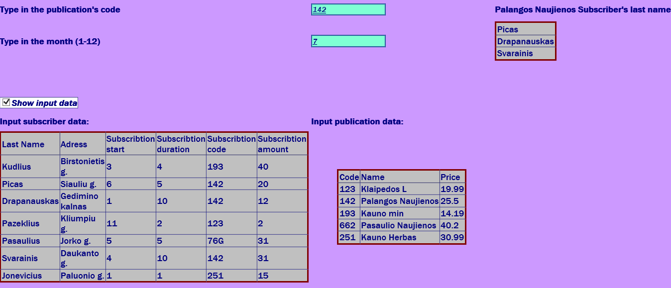

**Antras bandymas**

**U3a.txt - tuščias**

**U3b.txt**

Kudlius;Birstonietis g.;3;4;193;40

Picas;Siauliu g.;6;5;142;20

Drapanauskas;Gedimino kalnas;1;10;142;12

Pazeklius;Kliumpiu g.;11;2;123;2

Pasaulius;Jorko g.;5;5;76G;31

Svarainis;Daukanto g.;4;10;142;31

Jonevicius;Paluonio g.;1;1;251;15

**Answer.txt**

LastName | Adress | Subscribtion Start | Subscribtion Duration | Subscribtion Code | Subscribtion Amount |

---------------------------------------------------------------------------------------------------------------------------------------------------

Kudlius | Birstonietis g. | 3 | 4 | 193 | 40 |

---------------------------------------------------------------------------------------------------------------------------------------------------

Picas | Siauliu g. | 6 | 5 | 142 | 20 |

---------------------------------------------------------------------------------------------------------------------------------------------------

Drapanauskas | Gedimino kalnas | 1 | 10 | 142 | 12 |

---------------------------------------------------------------------------------------------------------------------------------------------------

Pazeklius | Kliumpiu g. | 11 | 2 | 123 | 2 |

---------------------------------------------------------------------------------------------------------------------------------------------------

Pasaulius | Jorko g. | 5 | 5 | 76G | 31 |

---------------------------------------------------------------------------------------------------------------------------------------------------

Svarainis | Daukanto g. | 4 | 10 | 142 | 31 |

---------------------------------------------------------------------------------------------------------------------------------------------------

Jonevicius | Paluonio g. | 1 | 1 | 251 | 15 |

---------------------------------------------------------------------------------------------------------------------------------------------------

**Vartotojo sąsaja**

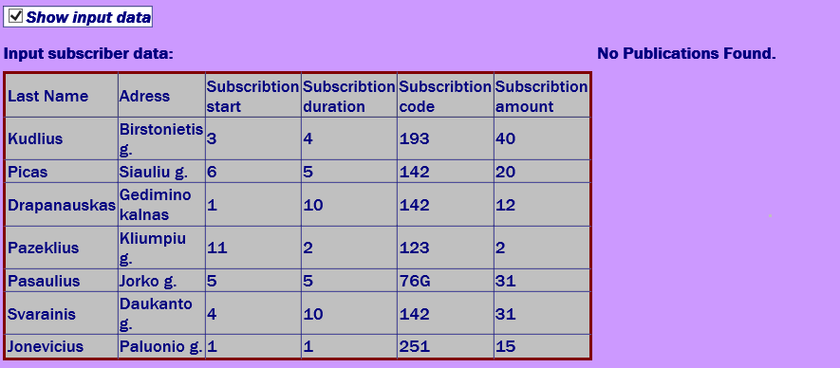

**Trečias bandymas:**

U3a.txt ir U3b.txt yra tokie patys, kaip pirmame bandyme, tačiau į teksto laukus įvedus 162 ir 5 programa neranda prenumeratorių.



**Ketvirtas bandymas:**

**U3a.txt**

123;Klaipedos L;19.99

142;Palangos Naujienos;25.50

193;Kauno min;14.19

662;Pasaulio Naujienos;40.20

251;Kauno Herbas;30.99

**U3b.txt**

Zajancas;Birstonietis g.;3;4;193;40

Rapanauskas;Siauliu g.;6;5;142;20

Drapanauskas;Gedimino kalnas;1;12;251;12

Solovjov;Dubai city;2;10;662;2

Juozapauskas;Kazkurios g.;2;7;193;12

Svenciulis;Klaipedos g.;1;12;123;13

Pazekius;Kliumpiu g.;11;2;123;2

**Answer.txt**

LastName | Adress | Subscribtion Start | Subscribtion Duration | Subscribtion Code | Subscribtion Amount |

---------------------------------------------------------------------------------------------------------------------------------------------------

Zajancas | Birstonietis g. | 3 | 4 | 193 | 40 |

---------------------------------------------------------------------------------------------------------------------------------------------------

Rapanauskas | Siauliu g. | 6 | 5 | 142 | 20 |

---------------------------------------------------------------------------------------------------------------------------------------------------

Drapanauskas | Gedimino kalnas | 1 | 12 | 251 | 12 |

---------------------------------------------------------------------------------------------------------------------------------------------------

Solovjov | Dubai city | 2 | 10 | 662 | 2 |

---------------------------------------------------------------------------------------------------------------------------------------------------

Juozapauskas | Kazkurios g. | 2 | 7 | 193 | 12 |

---------------------------------------------------------------------------------------------------------------------------------------------------

Svenciulis | Klaipedos g. | 1 | 12 | 123 | 13 |

---------------------------------------------------------------------------------------------------------------------------------------------------

Pazekius | Kliumpiu g. | 11 | 2 | 123 | 2 |

---------------------------------------------------------------------------------------------------------------------------------------------------

Code | Name | Price |

-------------------------------------------

123 | Klaipedos L | 19.99 |

-------------------------------------------

142 | Palangos Naujienos | 25.5 |

-------------------------------------------

193 | Kauno min | 14.19 |

-------------------------------------------

662 | Pasaulio Naujienos | 40.2 |

-------------------------------------------

251 | Kauno Herbas | 30.99 |

-------------------------------------------

Highest income every month:

1 . | Kauno Herbas|

2 . | Kauno Herbas|

3 . | Kauno min|

4 . | Kauno min|

5 . | Kauno min|

6 . | Kauno min|

7 . | Palangos Naujienos|

8 . | Palangos Naujienos|

9 . | Palangos Naujienos|

10. | Palangos Naujienos|

11. | Kauno Herbas|

12. | Kauno Herbas|

All Publication income: 14477.32

Below average income publications

Code | Name | Price |

-------------------------------------------

142 | Palangos Naujienos | 25.5 |

-------------------------------------------

662 | Pasaulio Naujienos | 40.2 |

-------------------------------------------

**Vartotojo sąsaja**

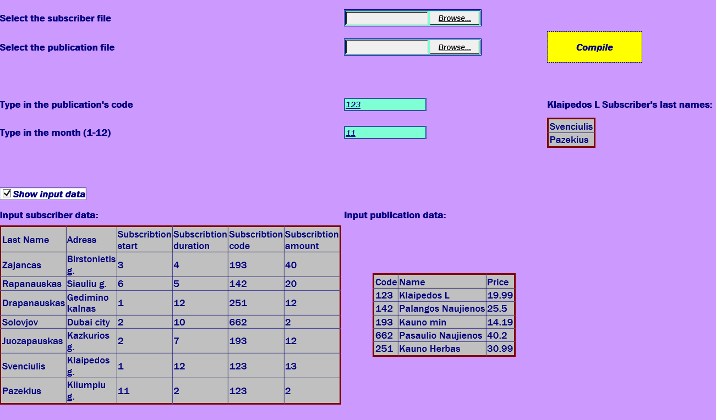

## Dėstytojo pastabos

Testo rezultatas:1;

# Kolekcijos ir išimčių valdymas (L4)

## Darbo užduotis

**LDD_4. Žaidėjai.** Pirmojoje failo eilutėje nurodyta rungtynių data (failų daug). Tolesnėse eilutėse nurodyta komandos pavadinimas, krepšininko pavardė, vardas, žaistų minučių skaičius, pelnytų taškų skaičius, padarytų klaidų skaičius. Atskirame faile nurodyta komandos pavadinimas, krepšininko pavardė, vardas, žaidimo pozicija (puolėjas, gynėjas, centras). Sudarykite nurodytos pozicijos (įvedama klaviatūra) nurodytame periode (įvedama klaviatūra, datos nuo iki) naudingiausių žaidėjų nurodyto kiekio (įvedama klaviatūra) sąrašą. Naudingiausias žaidėjas tas, kuris pelnė daugiausiai taškų, žaidė mažiausiai minučių ir padarė mažiausiai klaidų.

## Grafinės vartotojo sąsajos schema

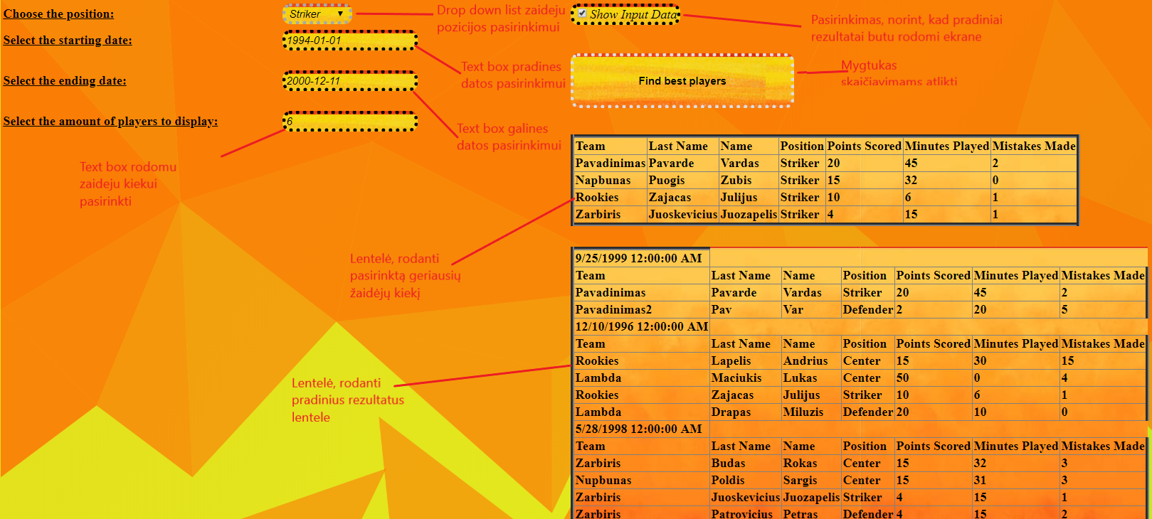

## Sąsajoje panaudotų komponentų keičiamos savybės

|  |  |  |
| --- | --- | --- |
| **Komponentas** | **Savybė** | **Reikšmė** |
| Label1 | Rodo tekstą | Nurodo, kad reikia pasirinkti poziciją |
| Label2 | Rodo tekstą | Nurodo, kad reikia įvesti datą |
| Label3 | Rodo tekstą | Nurodo, kad reikia įvesti datą |
| Label4 | Rodo tekstą | Nurodo, kad reikia nurodyti žaidėjų kiekį |
| DropDownList1 | Leidžia pasirinkti vieną iš pateiktų variantų | Pozicijos pasirinkimas |
| TextBox1 | Teksto įvedimui | Datos įvedimas |
| TextBox2 | Teksto įvedimui | Datos įvedimas |
| TextBox3 | Teksto įvedimui | Žaidėjų kiekio pasirinkimas |
| CheckBox1 | Pasrinkti taip arba ne | Pasirinkimas ar rodyti pradinius duomenis ar ne |
| Button1 | Paspaudžiamas | Atlieka skaičiavimus |
| Table1 | Rodyti informaciją lentele | Rodo rezultatus |
| Table2 | Rodyti informaciją lentele | Rodo pradinius duomenis |

## Klasių diagrama

|  |
| --- |
| **Forma.aspx.cs** |
| #Page_Load(in sender :object, in e :EventArgs)  #Button1_Click(in sender :object, in e :EventArgs)  +ReadData(, in dictionary :List<Player>>)  +ReadMatchData(in file :string, in list :List<Player>, )  +ReadPosition(in file :string, in list :List<Player>)  +FindBestPlayers(in WishedPosition :string, in StartD :DateTime, in EndD :DateTime, , in list :List<Player>>, in MaxPlayers :integer) : List<Player>  +GetBestPlayer(in list :List<Player>, in position :string) : Player  +RemovePlayer(, in list :List<Player>>, in toBeRemoved :Player)  +PrintInputDataToFile(in file :string, , in list :List<Player>>)  +PrintAnswersToFile(in file :string, in list :List<Player>, in position :string)  +PrintInputDataToTable(, in list :List<Player>>)  +PrintAnswersToTable(in list :List<Player>)  +FileExceptionControl(in filePaths :string[], in PlayerInfo :string)  +MatchFileControl(in val :string[], in counter :integer, in file :string)  +PlayerInfoControl(in val :string[], in counter :integer, in file :string)  +UserInterfaceExceptions(in S :DateTime, in E :DateTime, in Amount :string, in WPos :string)  +InputDataShow()  +EmptyFileException(in file :string) |

|  |
| --- |
| **Player.cs** |
| +Team : string  +LastName : string  +Name : string  +MinutesPlayed : integer  +PointsGained : integer  +MistakesMade : integer  +Position : string  +Player(in team :string, in lastName :string, in name :string, in minutesPlayed :integer, in pointsGained :integer, in mistakesMade :integer)  +Player(in team :string, in lastName :string, in name :string, in position :string)  +SetPosition(in position :string)  +CompareTo(in other :Player) : integer  +Equals(in other :Player) : boolean  +ToString() : string  +Header() : string |

## Programos vartotojo vadovas

Vartotojui įvedus norimą poziciją, pradinę ir galinę rungtynių data ir norimą žaidėjų kiekį ir paspaudus skaičiavimų mygtuką, lentele atspausdinami geriausi pasirinktos pozicijos žaidėjai. Vartotojas gali pasirinkti, kad progama rodytų ir pradinius duomenis. Tai gali padaryti uždėjęs varnelę Check box dezuteje pries atliekant skaičiavimus.

## Programos tekstas

**Player.cs**

using System;

using System.Collections.Generic;

using System.Linq;

using System.Web;

namespace _4lab

{

public class Player: IComparable<Player>, IEquatable<Player>

{

public string Team { get; set; }

public string LastName { get; set; }

public string Name { get; set; }

public int MinutesPlayed { get; set; }

public int PointsGained { get; set; }

public int MistakesMade { get; set; }

public string Position { get; set; }

/// <summary>

/// Player object constructor

/// </summary>

/// <param name="team"></param>

/// <param name="lastName"></param>

/// <param name="name"></param>

/// <param name="minutesPlayed"></param>

/// <param name="pointsGained"></param>

/// <param name="mistakesMade"></param>

public Player(string team, string lastName, string name, int minutesPlayed, int pointsGained, int mistakesMade)

{

Team = team;

LastName = lastName;

Name = name;

MinutesPlayed = minutesPlayed;

PointsGained = pointsGained;

MistakesMade = mistakesMade;

}

/// <summary>

/// playr object constructor

/// </summary>

/// <param name="team"></param>

/// <param name="lastName"></param>

/// <param name="name"></param>

/// <param name="position"></param>

public Player(string team, string lastName, string name, string position)

{

Team = team;

LastName = lastName;

Name = name;

Position = position;

}

/// <summary>

/// sets the postion from playerinfo file

/// </summary>

/// <param name="position"></param>

public void SetPosition(string position)

{

Position = position;

}

/// <summary>

/// compares players by points, minutes played and mistakes made

/// </summary>

/// <param name="other">other player</param>

/// <returns>integer</returns>

public int CompareTo(Player other)

{

if (this == null)

return 0;

if (other == null)

return 1;

if(PointsGained == other.PointsGained)

{

if (MinutesPlayed == other.MinutesPlayed)

return other.MistakesMade.CompareTo(MistakesMade);

return other.MinutesPlayed.CompareTo(MinutesPlayed);

}

return this.PointsGained.CompareTo(other.PointsGained);

}

/// <summary>

/// compares two players

/// </summary>

/// <param name="other">otehr player</param>

/// <returns>true or false</returns>

public bool Equals(Player other)

{

if (other == null)

return false;

if (LastName == other.LastName && Name == other.Name && Team == other.Team)

return true;

return false;

}

/// <summary>

/// Prinst out player information in a fromated string

/// </summary>

/// <returns>formated string </returns>

public override string ToString()

{

return String.Format("{0, 15} | {1, 15} | {2, 15} | {3, 15} | {4, 15} | {5, 15} | {6, 15} |", Team, LastName, Name, Position, PointsGained, MinutesPlayed, MistakesMade);

}

/// <summary>

/// prints the header of a table for the player object

/// </summary>

/// <returns>formated header</returns>

public string Header()

{

return String.Format("{0, 15} | {1, 15} | {2, 15} | {3, 15} | {4, 15} | {5, 15} | {6, 15} |", "Team", "LastName", "Name", "Position", "PointsGained", "MinutesPlayed", "MistakesMade");

}

}

}**Form.aspx.cs**

<%@ Page Language="C#" AutoEventWireup="true" CodeBehind="Form.aspx.cs" Inherits="_4lab.Form" %>

<!DOCTYPE html>

<html xmlns="http://www.w3.org/1999/xhtml">

<head runat="server">

<title></title>

<style type="text/css">

.auto-style1 {

width: 100%;

}

.auto-style2 {

width: 346px;

}

.auto-style3 {

width: 346px;

height: 33px;

}

.auto-style4 {

height: 33px;

}

DarkMode{

background-color: dimgray;

}

.auto-style6 {

height: 33px;

width: 357px;

}

.auto-style7 {

width: 357px;

}

.darker {

background-color: black;

}

.backgr{

background-color:dimgray

}

.Background{

background-image:url("Triangles.png");

width:100vw;

height:100vh;

background-size:100%;

margin-left:-7px;

margin-top:-7px;

}

.Tables{

background-image:url("TableB2.jpg");

text-decoration:double;

border-width: thick;

font-weight:900;

text-shadow:initial;

}

.Buttons{

background-image:url("TableB.jpg");

border-width: thick;

border-style: dotted;

width: 50%;

height: 200%;

cursor:pointer;

border-radius:10px;

}

.TextBox{

border-width:thick;

border-style:dotted;

background-image:url("TableB.jpg");

font-style:oblique;

cursor:text;

border-radius:10px;

}

.DropDownL {

border-width:thick;

border-style:dotted;

background-image:url("TableB.jpg");

font-style:oblique;

text-shadow:initial;

cursor:pointer;

border-radius:10px;

}

.LabelS{

font-weight:800;

font-size:16px;

text-decoration:underline;

}

@-a-keyframes rainbow {

0%{background-position:0% 82%}

50%{background-position:100% 19%}

100%{background-position:0% 82%}

}

@-b-keyframes rainbow {

0%{background-position:0% 82%}

50%{background-position:100% 19%}

100%{background-position:0% 82%}

}

@-c-keyframes rainbow {

0%{background-position:0% 82%}

50%{background-position:100% 19%}

100%{background-position:0% 82%}

}

@keyframes rainbow {

0%{background-position:0% 82%}

50%{background-position:100% 19%}

100%{background-position:0% 82%}

}

.wzoom{

background: linear-gradient(124deg, #ff2400, #e81d1d, #e8b71d, #e3e81d, #1de840, #1ddde8, #2b1de8, #dd00f3, #dd00f3);

//background-image:url("Triangles.png");

background-size: 1800% 1800%;

-a-animation: rainbow 18s ease infinite;

-b-animation: rainbow 18s ease infinite;

-b-animation: rainbow 18s ease infinite;

animation: rainbow 18s ease infinite;

}

</style>

</head>

<body class="wzoom" >

<div class="Background">

<form id="form1" runat="server">

<div>

<table class="auto-style1">

<tr>

<td class="auto-style3">

<asp:Label ID="Label1" runat="server" Text="Choose the position:" CssClass="LabelS"></asp:Label>

</td>

<td class="auto-style6">

<asp:DropDownList ID="DropDownList1" runat="server" CssClass="DropDownL">

</asp:DropDownList>

</td>

<td class="auto-style4">

<asp:CheckBox ID="CheckBox1" runat="server" CssClass="TextBox" Text="Show Input Data" />

</td>

</tr>

<tr>

<td class="auto-style2">

<asp:Label ID="Label2" runat="server" Text="Select the starting date:" CssClass="LabelS"></asp:Label>

</td>

<td class="auto-style7">

<asp:TextBox ID="TextBox1" runat="server" CssClass="TextBox"></asp:TextBox>

<asp:RequiredFieldValidator ID="RequiredFieldValidator2" runat="server" ControlToValidate="TextBox1" ErrorMessage="Starting date field has to be filled" ForeColor="Red">*</asp:RequiredFieldValidator>

</td>

<td>

&nbsp;</td>

</tr>

<tr>

<td class="auto-style2">

<asp:Label ID="Label3" runat="server" Text="Select the ending date:" CssClass="LabelS"></asp:Label>

</td>

<td class="auto-style7">

<asp:TextBox ID="TextBox2" runat="server" CssClass="TextBox"></asp:TextBox>

<asp:RequiredFieldValidator ID="RequiredFieldValidator3" runat="server" ControlToValidate="TextBox2" ErrorMessage="Starting date field has to be filled" ForeColor="Red">*</asp:RequiredFieldValidator>

</td>

<td>

<asp:Button ID="Button1" runat="server" Text="Find best players" OnClick="Button1_Click" CssClass="Buttons" Height="68px" Width="279px" Font-Bold="True" />

</td>

</tr>

<tr>

<td class="auto-style2">

<asp:Label ID="Label4" runat="server" Text="Select the amount of players to display:" CssClass="LabelS"></asp:Label>

</td>

<td class="auto-style7">

<asp:TextBox ID="TextBox3" runat="server" CssClass="TextBox"></asp:TextBox>

<asp:RequiredFieldValidator ID="RequiredFieldValidator4" runat="server" ControlToValidate="TextBox3" ErrorMessage="Starting date field has to be filled" ForeColor="Red">*</asp:RequiredFieldValidator>

</td>

<td>

&nbsp;</td>

</tr>

<tr>

<td class="auto-style2">

<asp:ValidationSummary ID="ValidationSummary1" runat="server" ForeColor="Red" />

</td>

<td class="auto-style7">

&nbsp;</td>

<td>

<asp:Table ID="Table2" runat="server" GridLines="Both" CssClass="Tables">

</asp:Table>

</td>

</tr>

<tr>

<td class="auto-style2">

&nbsp;</td>

<td class="auto-style7">&nbsp;</td>

<td>

&nbsp;</td>

</tr>

<tr>

<td class="auto-style2">

&nbsp;</td>

<td class="auto-style7">

&nbsp;</td>

<td>

<asp:Table ID="Table1" runat="server" GridLines="Both" CssClass="Tables" Height="19px">

</asp:Table>

</td>

</tr>

</table>

<br />

</div>

</form>

</div>

</body>

</html>

**Form.aspx**

using System;

using System.Collections.Generic;

using System.Linq;

using System.Web;

using System.Web.UI;

using System.Web.UI.WebControls;

using System.IO;

namespace _4lab

{

public partial class Form : System.Web.UI.Page

{

protected void Page_Load(object sender, EventArgs e)

{

if (DropDownList1.Items.Count == 0)

{

DropDownList1.Items.Add("-");

DropDownList1.Items.Add("Striker");

DropDownList1.Items.Add("Defender");

DropDownList1.Items.Add("Center");

}

}

protected void Button1_Click(object sender, EventArgs e)

{

UserInterfaceExceptions(TextBox1.Text, TextBox2.Text, TextBox3.Text, DropDownList1.SelectedValue);

string WantedPosition = DropDownList1.SelectedValue;

DateTime StartD = DateTime.Parse(TextBox1.Text);

DateTime EndD = DateTime.Parse(TextBox2.Text);

int PAmount = int.Parse(TextBox3.Text);

Dictionary<DateTime, List<Player>> MatchList = new Dictionary<DateTime, List<Player>>();

ReadData(MatchList);

PrintInputDataToFile("Answer.txt", MatchList);

PrintInputDataToTable(MatchList);

InputDataShow();

List<Player> BestPlayers = FindBestPlayers(WantedPosition, StartD, EndD, MatchList, PAmount);

PrintAnswersToFile("Answer.txt", BestPlayers, WantedPosition);

PrintAnswersToTable(BestPlayers);

}

#region Read Data

/// <summary>

/// Reads all files in given location that start with the string Match

/// </summary>

/// <param name="dictionary">the list that needs to be filled</param>

public void ReadData(Dictionary<DateTime, List<Player>> dictionary)

{

string[] filePaths = Directory.GetFiles(Server.MapPath(@"App_Data"), "Match*.txt");

string PlayerInfo = Server.MapPath(@"App_Data/PlayerInfo.txt");

FileExceptionControl(filePaths, PlayerInfo);

foreach (string path in filePaths)

{

List<Player> list = new List<Player>();

DateTime date;

ReadMatchData(path, list, out date);

ReadPosition(PlayerInfo, list);

dictionary.Add(date, list);

}

}

/// <summary>

/// Reads individual match file

/// </summary>

/// <param name="file">given match file</param>

/// <param name="list">given list</param>

/// <param name="date">date from the first line of the file</param>

public void ReadMatchData(string file, List<Player> list, out DateTime date)

{

using (StreamReader sr = new StreamReader(file))

{

int counter = 1;

EmptyFileException(file);

date = DateTime.Parse(sr.ReadLine());

string line;

while ((line = sr.ReadLine()) != null)

{

string[] val = line.Split(';');

MatchFileControl(val, counter, file);

string TName = val[0];

string LName = val[1];

string Name = val[2];

int MPlayed = int.Parse(val[3]);

int PScored = int.Parse(val[4]);

int MMade = int.Parse(val[5]);

Player pl = new Player(TName, LName, Name, MPlayed, PScored, MMade);

if (!list.Contains(pl))

list.Add(pl);

counter++;

}

}

}

/// <summary>

/// Reads the position file

/// </summary>

/// <param name="file">file location</param>

/// <param name="list">player list</param>

public void ReadPosition(string file, List<Player> list)

{

using (StreamReader sr = new StreamReader(file))

{

string line;

int counter = 1;

while ((line = sr.ReadLine()) != null)

{

string[] val = line.Split(';');

PlayerInfoControl(val, counter, file);

Player temp = new Player(val[0], val[1], val[2], val[3]);

for (int i = 0; i < list.Count; i++)

{

if (list[i].Equals(temp))

{

list[i].SetPosition(temp.Position);

break;

}

}

counter++;

}

}

}

#endregion

#region Get Best Players

/// <summary>

/// finds the best player from the list and deletes him after adding to new list

/// </summary>

/// <param name="WishedPosition">user chosen position</param>

/// <param name="StartD">user chosen starting date</param>

/// <param name="EndD">user chosen ending date</param>

/// <param name="list">the list of players </param>

/// <param name="MaxPlayers">The amount of players to be selected</param>

/// <returns>list of best players</returns>

public List<Player> FindBestPlayers(string WishedPosition, DateTime StartD, DateTime EndD, Dictionary<DateTime, List<Player>> list, int MaxPlayers)

{

List<Player> best = new List<Player>();

for (int i = 0; i < MaxPlayers; i++)

{

Player BestPlayer = null;

foreach (var entry in list)

{

if (entry.Key >= StartD && entry.Key <= EndD)

{

Player BestListP = GetBestPlayer(entry.Value, WishedPosition);

if (BestListP != null && BestListP.CompareTo(BestPlayer) > 0)

BestPlayer = BestListP;

}

}

RemovePlayer(list, BestPlayer);

if (BestPlayer != null)

best.Add(BestPlayer);

}

return best;

}

/// <summary>

/// Gets the best player from the given list

/// </summary>

/// <param name="list">given list</param>

/// <param name="position">user chosen position</param>

/// <returns>best player from the list</returns>

public Player GetBestPlayer(List<Player> list, string position)

{

Player BestP = null;

for (int i = 0; i < list.Count; i++)

{

if (list[i].Position == position && list[i].CompareTo(BestP) > 0)

BestP = list[i];

}

return BestP;

}

/// <summary>

/// Removes the chosen player from the list

/// </summary>

/// <param name="list">given list</param>

/// <param name="toBeRemoved">player that is chosen to be removed</param>

public void RemovePlayer(Dictionary<DateTime, List<Player>> list, Player toBeRemoved)

{

foreach (var entry in list)

{

entry.Value.Remove(toBeRemoved);

}

}

#endregion

#region Print Data

/// <summary>

/// Prints input data to answer file

/// </summary>

/// <param name="file">answer file location</param>

/// <param name="list">list to be printed</param>

public void PrintInputDataToFile(string file, Dictionary<DateTime, List<Player>> list)

{

using (StreamWriter sw = new StreamWriter(Server.MapPath(file)))

{

foreach (var entry in list)

{

if (entry.Value.Count != 0)

{

sw.WriteLine(entry.Key);

sw.WriteLine(entry.Value[0].Header());

sw.WriteLine(new string('-', entry.Value[0].Header().Length));

for (int i = 0; i < entry.Value.Count; i++)

sw.WriteLine(entry.Value[i].ToString());

sw.WriteLine();

}

else

{

sw.WriteLine(entry.Key);

sw.WriteLine("List is empty");

sw.WriteLine();

}

}

}

}

/// <summary>

/// Prints the answers to file

/// </summary>

/// <param name="file">file path</param>

/// <param name="list">given list</param>

/// <param name="position">user wished position</param>

public void PrintAnswersToFile(string file, List<Player> list, string position)

{

using (StreamWriter sw = new StreamWriter(Server.MapPath(file), true))

{

if (list.Count != 0)

{

sw.WriteLine("Chosen position by the user: {0}", position);

sw.WriteLine(list[0].Header());

sw.WriteLine(new string('-', list[0].Header().Length));

for (int i = 0; i < list.Count; i++)

sw.WriteLine(list[i].ToString());

sw.WriteLine();

}

else

sw.WriteLine("The list is empty");

}

}

/// <summary>

/// Prints input data to user interface

/// </summary>

/// <param name="list">given list</param>

public void PrintInputDataToTable(Dictionary<DateTime, List<Player>> list)

{

foreach (var entry in list)

{

TableRow row = new TableRow();

TableCell cella = new TableCell();

cella.Text = entry.Key.ToString();

row.Cells.Add(cella);

Table1.Rows.Add(row);

row = new TableRow();

TableCell[] cell = new TableCell[7];

for (int i = 0; i < 7; i++)

cell[i] = new TableCell();

cell[0].Text = "Team";

cell[1].Text = "Last Name";

cell[2].Text = "Name";

cell[3].Text = "Position";

cell[4].Text = "Points Scored";

cell[5].Text = "Minutes Played";

cell[6].Text = "Mistakes Made";

row.Cells.AddRange(cell);

Table1.Rows.Add(row);

for (int i = 0; i < entry.Value.Count; i++)

{

row = new TableRow();

for (int j = 0; j < 7; j++)

cell[j] = new TableCell();

cell[0].Text = entry.Value[i].Team;

cell[1].Text = entry.Value[i].LastName;

cell[2].Text = entry.Value[i].Name;

cell[3].Text = entry.Value[i].Position;

cell[4].Text = entry.Value[i].PointsGained.ToString();

cell[5].Text = entry.Value[i].MinutesPlayed.ToString();

cell[6].Text = entry.Value[i].MistakesMade.ToString();

row.Cells.AddRange(cell);

Table1.Rows.Add(row);

}

}

}

/// <summary>

/// Prints answers to user interface

/// </summary>

/// <param name="list">given list </param>

public void PrintAnswersToTable(List<Player> list)

{

TableRow row = new TableRow();

TableCell[] cell = new TableCell[7];

for (int i = 0; i < 7; i++)

cell[i] = new TableCell();

cell[0].Text = "Team";

cell[1].Text = "Last Name";

cell[2].Text = "Name";

cell[3].Text = "Position";

cell[4].Text = "Points Scored";

cell[5].Text = "Minutes Played";

cell[6].Text = "Mistakes Made";

row.Cells.AddRange(cell);

Table2.Rows.Add(row);

for (int i = 0; i < list.Count; i++)

{

row = new TableRow();

for (int j = 0; j < 7; j++)

cell[j] = new TableCell();

cell[0].Text = list[i].Team;

cell[1].Text = list[i].LastName;

cell[2].Text = list[i].Name;

cell[3].Text = list[i].Position;

cell[4].Text = list[i].PointsGained.ToString();

cell[5].Text = list[i].MinutesPlayed.ToString();

cell[6].Text = list[i].MistakesMade.ToString();

row.Cells.AddRange(cell);

Table2.Rows.Add(row);

}

}

#endregion

#region Exception Control

/// <summary>

/// Looks through file array, throws an exception if none are found

/// </summary>

/// <param name="filePaths">string array of files</param>

/// <param name="PlayerInfo">player info file path</param>

public void FileExceptionControl(string[] filePaths, string PlayerInfo)

{

try

{

if (filePaths.Length == 0) throw new Exception("Cannot find any Match*.txt files in given location");

else if (!File.Exists(PlayerInfo)) throw new Exception("Cannot find PlayerInfo.txt file in given location");

}

catch (Exception ex) { throw ex; }

}

/// <summary>

/// Looks for an error in the match files.

/// </summary>

/// <param name="val">player information</param>

/// <param name="counter">line counter</param>

/// <param name="file">file location</param>

public void MatchFileControl(string[] val, int counter, string file)

{

try

{

if (val.Length != 6) throw new Exception(String.Format("There is a mistake in line {0} in the file {1}.", counter, file));

for (int i = 3; i < 6; i++)

if (int.TryParse(val[i], out int rez) == false)

throw new Exception(string.Format("There is mistake in the line {0} in the file {1}. There should be a number instead of a char.", counter, file));

}

catch (Exception ex) { throw ex; }

}

/// <summary>

/// looks for mistakes in playerinfo file

/// </summary>

/// <param name="val">player information</param>

/// <param name="counter">line counter</param>

/// <param name="file">file path</param>

public void PlayerInfoControl(string[] val, int counter, string file)

{

try

{

if (val.Length != 4) throw new Exception(String.Format("There is a mistake in line {0} in the file {1}.", counter, file));

}

catch (Exception ex) { throw ex; }

}

/// <summary>

/// User interface exception control

/// </summary>

/// <param name="S">user selected starting date</param>

/// <param name="E">user selected ending date</param>

/// <param name="Amount">user selected amount of players</param>

/// <param name="WPos">user selected wanted position</param>

public void UserInterfaceExceptions(string S, string E, string Amount, string WPos)

{

try

{

if (DateTime.TryParse(S, out DateTime rez) == false)

throw new Exception(string.Format("Starting date is in the incorrect format."));

if (DateTime.TryParse(E, out DateTime rezz) == false)

throw new Exception(string.Format("Ending date is in the incorrect format."));

if (DateTime.Parse(E) < DateTime.Parse(S)) throw new Exception(string.Format("The starting date has to be before the ending date."));

if (WPos != "Striker" && WPos != "Defender" && WPos != "Center")

throw new Exception(string.Format("The chosen position does not exist."));

if (int.TryParse(Amount, out int rezzz) == false)

throw new Exception(string.Format("The chosen amount is not a number."));

}

catch (Exception ex) { throw ex; }

}

/// <summary>

/// checkbox for input data

/// </summary>

public void InputDataShow()

{

if (CheckBox1.Checked)

Table1.Visible = true;

if (!CheckBox1.Checked)

Table1.Visible = false;

}

/// <summary>

/// empty file exception control

/// </summary>

/// <param name="file">file path</param>

public void EmptyFileException(string file)

{

try

{

string[] a = File.ReadAllLines(file);

if (a.Length == 0)

throw new Exception(string.Format("The File {0} is empty", file));

}

catch (Exception ex) { throw ex; }

}

#endregion

}

}

## Pradiniai duomenys ir rezultatai

**Match1.txt:**

1999-09-25

Pavadinimas;Pavarde;Vardas;45;20;2

Pavadinimas2;Pav;Var;20;2;5

**Match2.txt**

1996-12-10

Rookies;Lapelis;Andrius;30;15;15

Lambda;Maciukis;Lukas;0;50;4

Rookies;Zajacas;Julijus;6;10;1

Lambda;Drapas;Miluzis;10;20;0

**Match3.txt**

1998-05-28

Zarbiris;Budas;Rokas;32;15;3

Nupbunas;Poldis;Sargis;31;15;3

Zarbiris;Juoskevicius;Juozapelis;15;4;1

Zarbiris;Patrovicius;Petras;15;4;2

Napbunas;Puogis;Zubis;32;15;0

Napbunas;Laurius;Aurius;29;2;4

Zarbiris;Nuokalnis;Laurius;2;2;5

Napbunas;Pagalius;Zitas;31;15;0

**Match4.txt**

1998-04-12

**PlayerInfo.txt**

Pavadinimas;Pavarde;Vardas;Striker

Pavadinimas2;Pav;Var;Defender

Rookies;Lapelis;Andrius;Center

Lambda;Maciukis;Lukas;Center

Rookies;Zajacas;Julijus;Striker

Lambda;Drapas;Miluzis;Defender

Zarbiris;Budas;Rokas;Center

Nupbunas;Poldis;Sargis;Center

Zarbiris;Juoskevicius;Juozapelis;Striker

Zarbiris;Patrovicius;Petras;Defender

Napbunas;Puogis;Zubis;Striker

Napbunas;Laurius;Aurius;Center

Zarbiris;Nuokalnis;Laurius;Center

Napbunas;Pagalius;Zitas;Center

**Answer.txt**

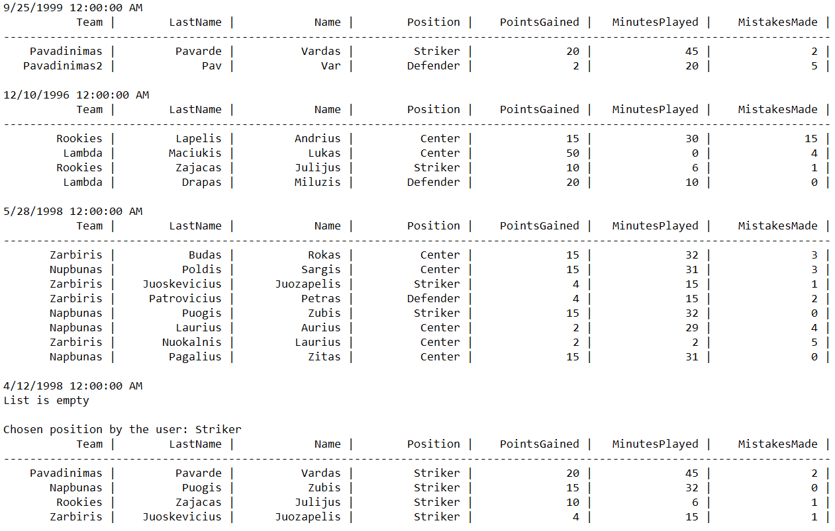

**2 bandymas:**

**Match1.txt**

1999-09-25

Pavadinimas;Pavarde;Vardas;45;20;2

Pavadinimas2;Pav;Var;20;2;5

**Match2.txt**

1996-12-10

Rookies;Lapelis;Andrius;30;15;15

Lambda;Maciukis;Lukas;20;31;4

Rookies;Zajacas;Julijus;6;10;1

Lambda;Drapas;Miluzis;10;20;0

**Match3.txt**

1998-05-28

Zarbiris;Budas;Rokas;32;15;3

Nupbunas;Poldis;Sargis;31;15;3

Zarbiris;Juoskevicius;Juozapelis;15;4;1

Zarbiris;Patrovicius;Petras;15;4;2

Napbunas;Puogis;Zubis;32;15;0

Napbunas;Laurius;Aurius;29;2;4

Zarbiris;Nuokalnis;Laurius;2;2;5

Napbunas;Pagalius;Zitas;31;15;0

**Match4.txt**

1998-04-12

Pomidorai;Kardas;Auksinis;29;15;3

Pomidorai;Princese;Auksuole;15;2;0

Agurkai;Giedriauskas;Lukis;0;0;0

Pomidorai;Faker;Drauguzis;5;2;4

Agurkai;Mandruolis;Sirijus;50;34;2

Agurkai;Poniulis;Dragunas;45;34;1

Pomidorai;Zykiukas;Sauliukas;45;34;0

**Match5.txt**

1976-04-20

Klumpakojai;Jaunoji;Aldona;20;9;3

Klumpakojai;Pirdzius;Tilius;30;21;0

Puodziai;Butrimas;Dalius;45;23;0

Puodziai;Kaztonius;Simas;30;21;1

Klumpakojai;Gelius;Juozapelis;60;49;1

Puodziai;Niukstis;Juonius;12;3;0

Klumpakojai;Baltrius;Justas;61;49;2

Puodziai;Saule;Jurgita;24;10;2

**PlayerInfo.txt**

Pavadinimas;Pavarde;Vardas;Striker

Pavadinimas2;Pav;Var;Defender

Rookies;Lapelis;Andrius;Center

Lambda;Maciukis;Lukas;Center

Rookies;Zajacas;Julijus;Striker

Lambda;Drapas;Miluzis;Defender

Zarbiris;Budas;Rokas;Center

Nupbunas;Poldis;Sargis;Center

Zarbiris;Juoskevicius;Juozapelis;Striker

Zarbiris;Patrovicius;Petras;Defender

Napbunas;Puogis;Zubis;Striker

Napbunas;Laurius;Aurius;Center

Zarbiris;Nuokalnis;Laurius;Center

Napbunas;Pagalius;Zitas;Center

Pomidorai;Kardas;Auksinis;Center

Pomidorai;Princese;Auksuole;Striker

Agurkai;Giedriauskas;Lukis;Defender

Pomidorai;Faker;Drauguzis;Striker

Agurkai;Mandruolis;Sirijus;Defender

Agurkai;Poniulis;Dragunas;Center

Pomidorai;Zykiukas;Sauliukas;Center

Klumpakojai;Jaunoji;Aldona;Center

Klumpakojai;Pirdzius;Tilius;Striker

Puodziai;Butrimas;Dalius;Striker

Puodziai;Kaztonius;Simas;Defender

Klumpakojai;Gelius;Juozapelis;Striker

Puodziai;Niukstis;Juonius;Defender

Klumpakojai;Baltrius;Justas;Center

Puodziai;Saule;Jurgita;Defender

Pasirinkus pradinę data 1960-01-01, galinę 2000-12-11, poziciją: Center, o rodomų žaidėjų skaičių 20, gaunami tokie atsakymai:

**Answer.txt**

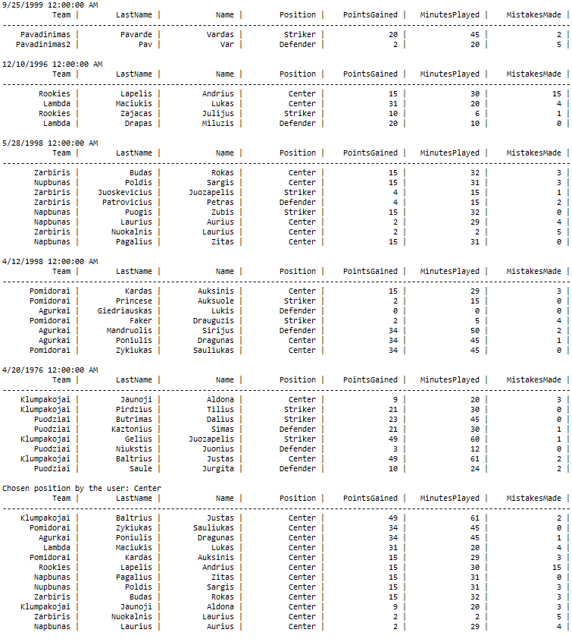

**Atsakymai vartotojo sąsajoje:**

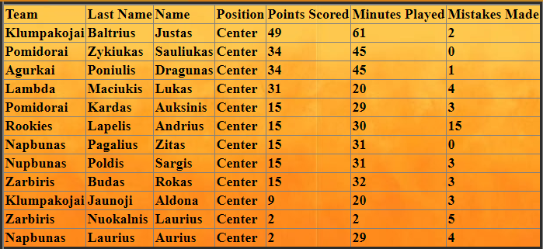

**3 bandymas:**

Šiame bandyme programai neduosime Match*.txt failų. Gausime tokį exception:



**4 bandymas:**

Dabar vartotojo sąsajoje įrašyisime netinkamus duomenis:

Nepasirinkę pozicijos, gauname tokį exception:



Įrašę netinkamą datą, gauname tokį exception:



Į player amound lauką įrašę ne skaičių, guname tokį exception:



## Dėstytojo pastabos

Testo rezultatas: 0;

# Deklaratyvusis programavimas (L5)

## Darbo užduotis

**LDD_5. Žaidėjai.** Pirmojoje failo eilutėje nurodyta rungtynių data (failų daug). Tolesnėse eilutėse nurodyta komandos pavadinimas, krepšininko pavardė, vardas, žaistų minučių skaičius, pelnytų taškų skaičius, padarytų klaidų skaičius. Atskirame faile nurodyta komandos pavadinimas, krepšininko pavardė, vardas, žaidimo pozicija (puolėjas, gynėjas, centras). Sudarykite nurodytos pozicijos (įvedama klaviatūra) nurodytame periode (įvedama klaviatūra, datos nuo iki) naudingiausių žaidėjų nurodyto kiekio (įvedama klaviatūra) sąrašą. Naudingiausias žaidėjas tas, kuris pelnė daugiausiai taškų, žaidė mažiausiai minučių ir padarė mažiausiai klaidų. Rikiuoti (komanda, krepšininko pavardė).

## Grafinės vartotojo sąsajos schema

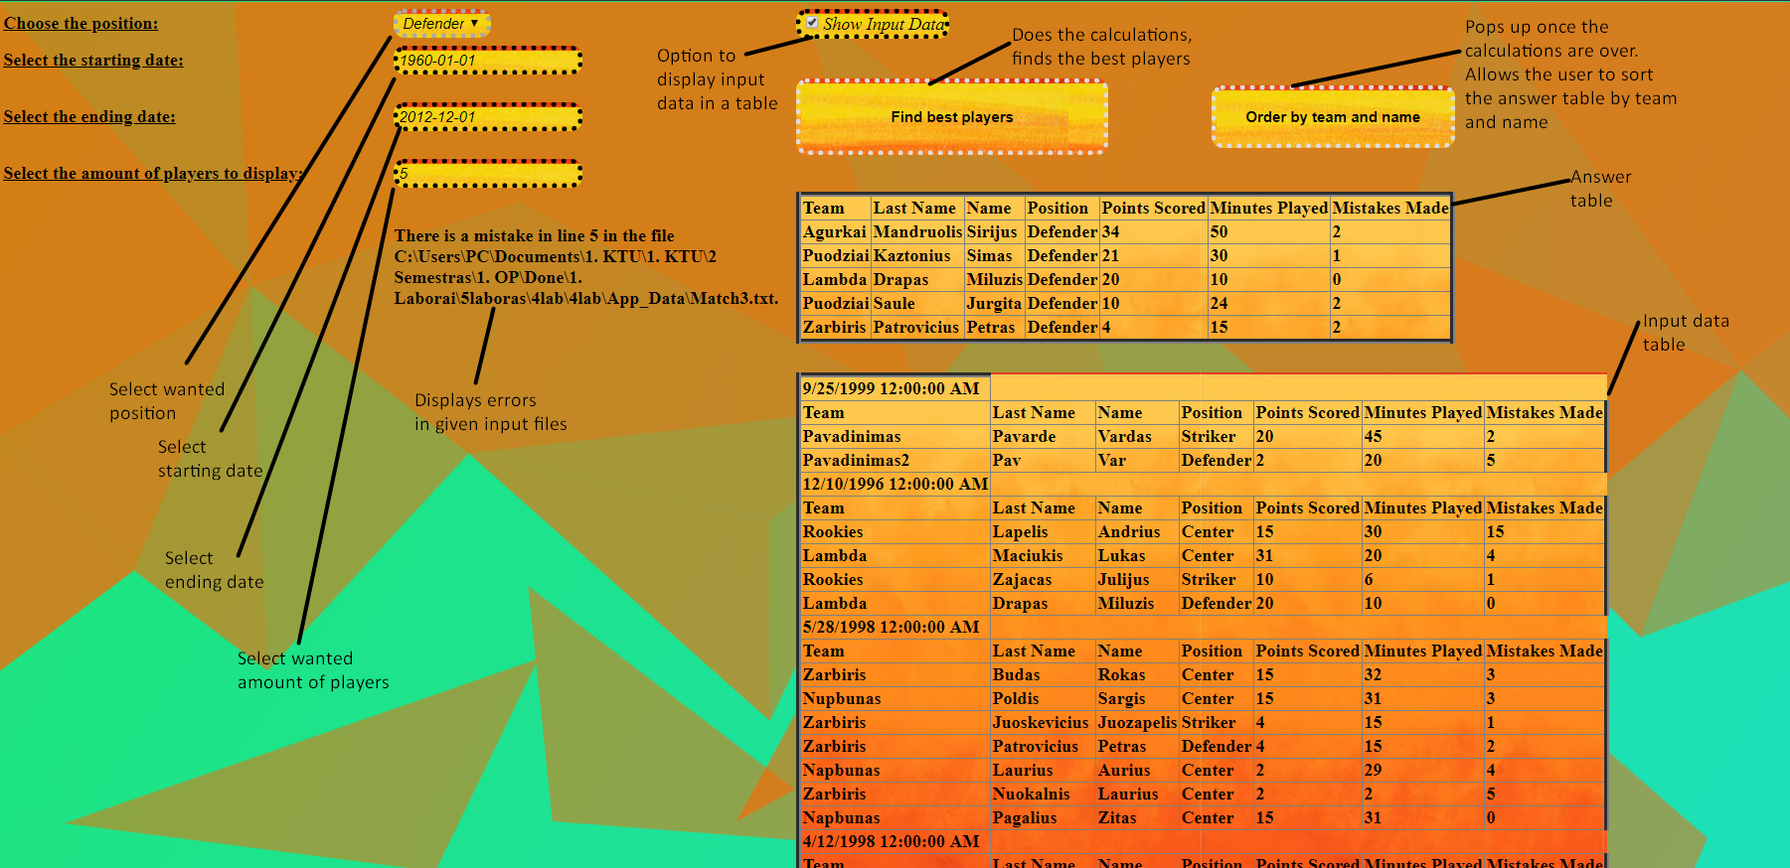

## Sąsajoje panaudotų komponentų keičiamos savybės

|  |  |  |
| --- | --- | --- |
| **Komponentas** | **Savybė** | **Reikšmė** |
| Label1 | Rodo tekstą | Nurodo, kad reikia pasirinkti poziciją |
| Label2 | Rodo tekstą | Nurodo, kad reikia įvesti datą |
| Label3 | Rodo tekstą | Nurodo, kad reikia įvesti datą |
| Label4 | Rodo tekstą | Nurodo, kad reikia nurodyti žaidėjų kiekį |
| Label5 | Rodo tekstą | Nurodo klaidas failuose |
| DropDownList1 | Leidžia pasirinkti vieną iš pateiktų variantų | Pozicijos pasirinkimas |
| TextBox1 | Teksto įvedimui | Datos įvedimas |
| TextBox2 | Teksto įvedimui | Datos įvedimas |
| TextBox3 | Teksto įvedimui | Žaidėjų kiekio pasirinkimas |
| CheckBox1 | Pasrinkti taip arba ne | Pasirinkimas ar rodyti pradinius duomenis ar ne |
| Button1 | Paspaudžiamas | Atlieka skaičiavimus |
| Button2 | Paspaudžiamas | Rikiuoja atsakymus pagal komandą ir vardą |
| Table1 | Rodyti informaciją lentele | Rodo rezultatus |
| Table2 | Rodyti informaciją lentele | Rodo pradinius duomenis |

## Klasių diagrama

|  |
| --- |
| Forma.aspx.cs |
| -BestPlayers : List<Player>  -List<Player>> : Dictionary<DateTime,  #Page_Load(in sender :object, in e :EventArgs)  #Button1_Click(in sender :object, in e :EventArgs)  #Button2_Click(in sender :object, in e :EventArgs)  +ReadData(, in dictionary :List<Player>>)  +ReadMatchData(in file :string, in list :List<Player>, )  +ReadPosition(in file :string, in list :List<Player>)  +FindBestPlayers(in WishedPosition :string, in StartD :DateTime, in EndD :DateTime, , in list :List<Player>>, in MaxPlayers :integer) : List<Player>  +PrintInputDataToFile(in file :string, , in list :List<Player>>)  +PrintAnswersToFile(in file :string, in list :List<Player>, in position :string)  +PrintInputDataToTable(, in list :List<Player>>)  +PrintAnswersToTable(in list :List<Player>)  +FileExceptionControl(in filePaths :string[], in PlayerInfo :string)  +MatchFileControl(in val :string[], in counter :integer, in file :string) : boolean  +PlayerInfoControl(in val :string[], in counter :integer, in file :string) : boolean  +UserInterfaceExceptions(in S :string, in E :string, in Amount :string, in WPos :string)  +InputDataShow()  +EmptyFileException(in file :string) |

|  |
| --- |
| Player.cs |
| +Team : string  +LastName : string  +Name : string  +MinutesPlayed : integer  +PointsGained : integer  +MistakesMade : integer  +Position : string  +Player(in team :string, in lastName :string, in name :string, in minutesPlayed :integer, in pointsGained :integer, in mistakesMade :integer)  +Player(in team :string, in lastName :string, in name :string, in position :string)  +SetPosition(in position :string)  +CompareTo(in other :Player) : integer  +Equals(in other :Player) : boolean  +ToString() : string  +Header() : string |

## Programos vartotojo vadovas

Vartotojui įvedus norimą poziciją, pradinę ir galinę rungtynių datas ir norimą žaidėjų kiekį ir paspaudus skaičiavimų mygtuką, lentele atspausdinami geriausi pasirinktos pozicijos žaidėjai. Vartotojas gali pasirinkti, kad progama rodytų ir pradinius duomenis. Tai gali padaryti uždėjęs varnelę Check box dezuteje pries atliekant skaičiavimus. Programai atlikus skaičiavimus atsiranda dar vienas mygtukas. Jį paspaudus programa išrikiuoja geriausių žaidėjų lentelę pagal komandos pavadinimą ir žaidėjų pavardes. Failuose esant klaidoms, programa praleidžia klaidingas eilutes, atlikdama skaičiavimus su kitomis eilutėmis. Vartotojas yra pranešamas apie klaidingas eilutes vartotojo sąsajoje.

## Programos tekstas

**Player.cs**

using System;

using System.Collections.Generic;

using System.Linq;

using System.Web;

namespace _4lab

{

public class Player: IComparable<Player>, IEquatable<Player>

{

public string Team { get; set; }

public string LastName { get; set; }

public string Name { get; set; }

public int MinutesPlayed { get; set; }

public int PointsGained { get; set; }

public int MistakesMade { get; set; }

public string Position { get; set; }

/// <summary>

/// Player object constructor

/// </summary>

/// <param name="team"></param>

/// <param name="lastName"></param>

/// <param name="name"></param>

/// <param name="minutesPlayed"></param>

/// <param name="pointsGained"></param>

/// <param name="mistakesMade"></param>

public Player(string team, string lastName, string name, int minutesPlayed, int pointsGained, int mistakesMade)

{

Team = team;

LastName = lastName;

Name = name;

MinutesPlayed = minutesPlayed;

PointsGained = pointsGained;

MistakesMade = mistakesMade;

}

/// <summary>

/// playr object constructor

/// </summary>

/// <param name="team"></param>

/// <param name="lastName"></param>

/// <param name="name"></param>

/// <param name="position"></param>

public Player(string team, string lastName, string name, string position)

{

Team = team;

LastName = lastName;

Name = name;

Position = position;

}

/// <summary>

/// sets the postion from playerinfo file

/// </summary>

/// <param name="position"></param>

public void SetPosition(string position)

{

Position = position;

}

/// <summary>

/// compares players by points, minutes played and mistakes made

/// </summary>

/// <param name="other">other player</param>

/// <returns>integer</returns>

public int CompareTo(Player other)

{

if (this == null)

return 0;

if (other == null)

return 1;

if(PointsGained == other.PointsGained)

{

if (MinutesPlayed == other.MinutesPlayed)

return other.MistakesMade.CompareTo(MistakesMade);

return other.MinutesPlayed.CompareTo(MinutesPlayed);

}

return this.PointsGained.CompareTo(other.PointsGained);

}

/// <summary>

/// compares two players

/// </summary>

/// <param name="other">otehr player</param>

/// <returns>true or false</returns>

public bool Equals(Player other)

{

if (other == null)

return false;

if (LastName == other.LastName && Name == other.Name && Team == other.Team)

return true;

return false;

}

/// <summary>

/// Prinst out player information in a fromated string

/// </summary>

/// <returns>formated string </returns>

public override string ToString()

{

return String.Format("{0, 15} | {1, 15} | {2, 15} | {3, 15} | {4, 15} | {5, 15} | {6, 15} |", Team, LastName, Name, Position, PointsGained, MinutesPlayed, MistakesMade);

}

/// <summary>

/// prints the header of a table for the player object

/// </summary>

/// <returns>formated header</returns>

public string Header()

{

return String.Format("{0, 15} | {1, 15} | {2, 15} | {3, 15} | {4, 15} | {5, 15} | {6, 15} |", "Team", "LastName", "Name", "Position", "PointsGained", "MinutesPlayed", "MistakesMade");

}

}

}

**Forma.aspx.cs**

using System;

using System.Collections.Generic;

using System.Linq;

using System.Web;

using System.Web.UI;

using System.Web.UI.WebControls;

using System.IO;

using System.Linq.Expressions;

namespace _4lab

{

public partial class Form : System.Web.UI.Page

{

private List<Player> BestPlayers;

private Dictionary<DateTime, List<Player>> MatchList;

protected void Page_Load(object sender, EventArgs e)

{

BestPlayers = (List<Player>)Session["Best"];

MatchList = (Dictionary<DateTime, List<Player>>)Session["Input"];

if (DropDownList1.Items.Count == 0)

{

DropDownList1.Items.Add("-");

DropDownList1.Items.Add("Striker");

DropDownList1.Items.Add("Defender");

DropDownList1.Items.Add("Center");

}

}

protected void Button1_Click(object sender, EventArgs e)

{

UserInterfaceExceptions(TextBox1.Text, TextBox2.Text, TextBox3.Text, DropDownList1.SelectedValue);

string WantedPosition = DropDownList1.SelectedValue;

DateTime StartD = DateTime.Parse(TextBox1.Text);

DateTime EndD = DateTime.Parse(TextBox2.Text);

int PAmount = int.Parse(TextBox3.Text);

Dictionary<DateTime, List<Player>> MatchList = new Dictionary<DateTime, List<Player>>();

ReadData(MatchList);

PrintInputDataToFile("Answer.txt", MatchList);

PrintInputDataToTable(MatchList);

InputDataShow();

List<Player> BestPlayers = FindBestPlayers(WantedPosition, StartD, EndD, MatchList, PAmount);

PrintAnswersToFile("Answer.txt", BestPlayers, WantedPosition);

PrintAnswersToTable(BestPlayers);

Session["Best"] = BestPlayers;

Session["Input"] = MatchList;

Button2.Visible = true;

}

/// <summary>

/// Second button for sorting

/// </summary>

/// <param name="sender"></param>

/// <param name="e"></param>

protected void Button2_Click(object sender, EventArgs e)

{

BestPlayers = BestPlayers.OrderBy(x => x.Team).ThenBy(x => x.LastName).ToList();

PrintAnswersToTable(BestPlayers);

if (CheckBox1.Checked == true)

PrintInputDataToTable(MatchList);

}

#region Read Data

/// <summary>

/// Reads all files in given location that start with the string Match

/// </summary>

/// <param name="dictionary">the list that needs to be filled</param>

public void ReadData(Dictionary<DateTime, List<Player>> dictionary)

{

string[] filePaths = Directory.GetFiles(Server.MapPath(@"App_Data"), "Match*.txt");

string PlayerInfo = Server.MapPath(@"App_Data/PlayerInfo.txt");

FileExceptionControl(filePaths, PlayerInfo);

foreach (string path in filePaths)

{

List<Player> list = new List<Player>();

DateTime date;

ReadMatchData(path, list, out date);

ReadPosition(PlayerInfo, list);

dictionary.Add(date, list);

}

}

/// <summary>

/// Reads individual match file

/// </summary>

/// <param name="file">given match file</param>

/// <param name="list">given list</param>

/// <param name="date">date from the first line of the file</param>

public void ReadMatchData(string file, List<Player> list, out DateTime date)

{

using (StreamReader sr = new StreamReader(file))

{

int counter = 1;

EmptyFileException(file);

date = DateTime.Parse(sr.ReadLine());

string line;

while ((line = sr.ReadLine()) != null)

{

string[] val = line.Split(';');

if (MatchFileControl(val, counter, file))

continue;

string TName = val[0];

string LName = val[1];

string Name = val[2];

int MPlayed = int.Parse(val[3]);

int PScored = int.Parse(val[4]);

int MMade = int.Parse(val[5]);

Player pl = new Player(TName, LName, Name, MPlayed, PScored, MMade);

if (!list.Contains(pl))

list.Add(pl);

counter++;

}

}

}

/// <summary>

/// Reads the position file

/// </summary>

/// <param name="file">file location</param>

/// <param name="list">player list</param>

public void ReadPosition(string file, List<Player> list)

{

using (StreamReader sr = new StreamReader(file))

{

string line;

int counter = 1;

while ((line = sr.ReadLine()) != null)

{

string[] val = line.Split(';');

if (PlayerInfoControl(val, counter, file))

continue;

var a = list.Find(x => x.Team == val[0] && x.LastName == val[1] && x.Name == val[2]);

if (a != null) a.SetPosition(val[3]);

counter++;

}

}

}

#endregion

#region Get Best Players

/// <summary>

/// finds the best player from the list and deletes him after adding to new list

/// </summary>

/// <param name="WishedPosition">user chosen position</param>

/// <param name="StartD">user chosen starting date</param>

/// <param name="EndD">user chosen ending date</param>

/// <param name="list">the list of players </param>

/// <param name="MaxPlayers">The amount of players to be selected</param>

/// <returns>list of best players</returns>

public List<Player> FindBestPlayers(string WishedPosition, DateTime StartD, DateTime EndD, Dictionary<DateTime, List<Player>> list, int MaxPlayers)

{

return list.Where(nn => nn.Key >= StartD && nn.Key <= EndD).SelectMany(nn => nn.Value)

.Where(nn => nn.Position == WishedPosition).ToList().OrderByDescending(nn => nn.PointsGained)

.ThenBy(nn => nn.MinutesPlayed).ThenBy(nn => nn.MistakesMade).Take(MaxPlayers).ToList();

}

#endregion

#region Print Data

/// <summary>

/// Prints input data to answer file

/// </summary>

/// <param name="file">answer file location</param>

/// <param name="list">list to be printed</param>

public void PrintInputDataToFile(string file, Dictionary<DateTime, List<Player>> list)

{

using (StreamWriter sw = new StreamWriter(Server.MapPath(file)))

{

foreach (var entry in list)

{

if (entry.Value.Count != 0)

{

sw.WriteLine(entry.Key);

sw.WriteLine(entry.Value[0].Header());

sw.WriteLine(new string('-', entry.Value[0].Header().Length));

entry.Value.ForEach(aa => { sw.WriteLine(aa.ToString()); });

sw.WriteLine();

}

else

{

sw.WriteLine(entry.Key);

sw.WriteLine("List is empty");

sw.WriteLine();

}

}

}

}

/// <summary>

/// Prints the answers to file

/// </summary>

/// <param name="file">file path</param>

/// <param name="list">given list</param>

/// <param name="position">user wished position</param>

public void PrintAnswersToFile(string file, List<Player> list, string position)

{

using (StreamWriter sw = new StreamWriter(Server.MapPath(file), true))

{

if (list.Count != 0)

{

sw.WriteLine("Chosen position by the user: {0}", position);

sw.WriteLine(list[0].Header());

sw.WriteLine(new string('-', list[0].Header().Length));

for (int i = 0; i < list.Count; i++)

sw.WriteLine(list[i].ToString());

sw.WriteLine();

}

else

sw.WriteLine("The list is empty");

}

}

/// <summary>

/// Prints input data to user interface

/// </summary>

/// <param name="list">given list</param>

public void PrintInputDataToTable(Dictionary<DateTime, List<Player>> list)

{

foreach (var entry in list)

{

TableRow row = new TableRow();

TableCell cella = new TableCell();

cella.Text = entry.Key.ToString();

row.Cells.Add(cella);

Table1.Rows.Add(row);

row = new TableRow();

TableCell[] cell = new TableCell[7];

for (int i = 0; i < 7; i++)

cell[i] = new TableCell();

cell[0].Text = "Team";

cell[1].Text = "Last Name";

cell[2].Text = "Name";

cell[3].Text = "Position";

cell[4].Text = "Points Scored";

cell[5].Text = "Minutes Played";

cell[6].Text = "Mistakes Made";

row.Cells.AddRange(cell);

Table1.Rows.Add(row);

for (int i = 0; i < entry.Value.Count; i++)

{

row = new TableRow();

for (int j = 0; j < 7; j++)

cell[j] = new TableCell();

cell[0].Text = entry.Value[i].Team;

cell[1].Text = entry.Value[i].LastName;

cell[2].Text = entry.Value[i].Name;

cell[3].Text = entry.Value[i].Position;

cell[4].Text = entry.Value[i].PointsGained.ToString();

cell[5].Text = entry.Value[i].MinutesPlayed.ToString();

cell[6].Text = entry.Value[i].MistakesMade.ToString();

row.Cells.AddRange(cell);

Table1.Rows.Add(row);

}

}

}

/// <summary>

/// Prints answers to user interface

/// </summary>

/// <param name="list">given list </param>

public void PrintAnswersToTable(List<Player> list)

{

TableRow row = new TableRow();

TableCell[] cell = new TableCell[7];

for (int i = 0; i < 7; i++)

cell[i] = new TableCell();

cell[0].Text = "Team";

cell[1].Text = "Last Name";

cell[2].Text = "Name";

cell[3].Text = "Position";

cell[4].Text = "Points Scored";

cell[5].Text = "Minutes Played";

cell[6].Text = "Mistakes Made";

row.Cells.AddRange(cell);

Table2.Rows.Add(row);

for (int i = 0; i < list.Count; i++)

{

row = new TableRow();

for (int j = 0; j < 7; j++)

cell[j] = new TableCell();

cell[0].Text = list[i].Team;

cell[1].Text = list[i].LastName;

cell[2].Text = list[i].Name;

cell[3].Text = list[i].Position;

cell[4].Text = list[i].PointsGained.ToString();

cell[5].Text = list[i].MinutesPlayed.ToString();

cell[6].Text = list[i].MistakesMade.ToString();

row.Cells.AddRange(cell);

Table2.Rows.Add(row);

}

}

#endregion

#region Exception Control

/// <summary>

/// Looks through file array, throws an exception if none are found

/// </summary>

/// <param name="filePaths">string array of files</param>

/// <param name="PlayerInfo">player info file path</param>

public void FileExceptionControl(string[] filePaths, string PlayerInfo)

{

try

{

if (filePaths.Length == 0) throw new Exception("Cannot find any Match*.txt files in given location");

else if (!File.Exists(PlayerInfo)) throw new Exception("Cannot find PlayerInfo.txt file in given location");

}

catch (Exception ex) { throw ex; }

}

/// <summary>

/// Looks for an error in the match files.

/// </summary>

/// <param name="val">player information</param>

/// <param name="counter">line counter</param>

/// <param name="file">file location</param>

public bool MatchFileControl(string[] val, int counter, string file)

{

try

{

if (val.Length != 6) throw new Exception(String.Format("There is a mistake in line {0} in the file {1}.", counter, file));

for (int i = 3; i < 6; i++)

if (int.TryParse(val[i], out int rez) == false)

throw new Exception(string.Format("There is mistake in the line {0} in the file {1}. There should be a number instead of a char.", counter, file));

}

catch (Exception)

{

Label5.Text += String.Format("There is a mistake in line {0} in the file {1}.{2}", counter, file, Environment.NewLine);

return true;

}

return false;

}

/// <summary>

/// looks for mistakes in playerinfo file

/// </summary>

/// <param name="val">player information</param>

/// <param name="counter">line counter</param>

/// <param name="file">file path</param>

public bool PlayerInfoControl(string[] val, int counter, string file)

{

try

{

if (val.Length != 4) throw new Exception(String.Format("There is a mistake in line {0} in the file {1}.", counter, file));

}

catch (Exception)

{

if (!Label5.Text.Contains(String.Format("There is a mistake in line {0} in the file {1}.", counter, file)))

Label5.Text += String.Format("There is a mistake in line {0} in the file {1}.{2}", counter, file, Environment.NewLine);

return true;

}

return false;

}

/// <summary>

/// User interface exception control

/// </summary>

/// <param name="S">user selected starting date</param>

/// <param name="E">user selected ending date</param>

/// <param name="Amount">user selected amount of players</param>

/// <param name="WPos">user selected wanted position</param>

public void UserInterfaceExceptions(string S, string E, string Amount, string WPos)

{

try

{

if (DateTime.TryParse(S, out DateTime rez) == false)

throw new Exception(string.Format("Starting date is in the incorrect format."));

if (DateTime.TryParse(E, out DateTime rezz) == false)

throw new Exception(string.Format("Ending date is in the incorrect format."));

if (DateTime.Parse(E) < DateTime.Parse(S))

throw new Exception(string.Format("The starting date has to be before the ending date."));

if (WPos != "Striker" && WPos != "Defender" && WPos != "Center")

throw new Exception(string.Format("The chosen position does not exist."));

if (int.TryParse(Amount, out int rezzz) == false)

throw new Exception(string.Format("The chosen amount is not a number."));

}

catch (Exception ex) { throw ex; }

}

/// <summary>

/// checkbox for input data

/// </summary>

public void InputDataShow()

{

if (CheckBox1.Checked)

Table1.Visible = true;

if (!CheckBox1.Checked)

Table1.Visible = false;

}

/// <summary>

/// empty file exception control

/// </summary>

/// <param name="file">file path</param>

public void EmptyFileException(string file)

{

try

{

string[] a = File.ReadAllLines(file);

if (a.Length == 0)

throw new Exception(string.Format("The File {0} is empty", file));

}

catch (Exception ex) { throw ex; }

}

#endregion

}

}

## Pradiniai duomenys ir rezultatai

**Pirmas bandymas:**

**Match1.txt:**

1999-09-25

Pavadinimas;Pavarde;Vardas;45;20;2

Pavadinimas2;Pav;Var;20;2;5

**Match2.txt**

1996-12-10

Rookies;Lapelis;Andrius;30;15;15

Lambda;Maciukis;Lukas;0;50;4

Rookies;Zajacas;Julijus;6;10;1

Lambda;Drapas;Miluzis;10;20;0

**Match3.txt**

1998-05-28

Zarbiris;Budas;Rokas;32;15;3

Nupbunas;Poldis;Sargis;31;15;3

Zarbiris;Juoskevicius;Juozapelis;15;4;1

Zarbiris;Patrovicius;Petras;15;4;2

Napbunas;Puogis;Zubis;32;15;0

Napbunas;Laurius;Aurius;29;2;4

Zarbiris;Nuokalnis;Laurius;2;2;5

Napbunas;Pagalius;Zitas;31;15;0

**Match4.txt**

1998-04-12

**PlayerInfo.txt**

Pavadinimas;Pavarde;Vardas;Striker

Pavadinimas2;Pav;Var;Defender

Rookies;Lapelis;Andrius;Center

Lambda;Maciukis;Lukas;Center

Rookies;Zajacas;Julijus;Striker

Lambda;Drapas;Miluzis;Defender

Zarbiris;Budas;Rokas;Center

Nupbunas;Poldis;Sargis;Center

Zarbiris;Juoskevicius;Juozapelis;Striker

Zarbiris;Patrovicius;Petras;Defender

Napbunas;Puogis;Zubis;Striker

Napbunas;Laurius;Aurius;Center

Zarbiris;Nuokalnis;Laurius;Center

Napbunas;Pagalius;Zitas;Center

**Answer.txt**



**2 bandymas:**

**Match1.txt**

1999-09-25

Pavadinimas;Pavarde;Vardas;45;20;2

Pavadinimas2;Pav;Var;20;2;5

**Match2.txt**

1996-12-10

Rookies;Lapelis;Andrius;30;15;15

Lambda;Maciukis;Lukas;20;31;4

Rookies;Zajacas;Julijus;6;10;1

Lambda;Drapas;Miluzis;10;20;0

**Match3.txt**

1998-05-28

Zarbiris;Budas;Rokas;32;15;3

Nupbunas;Poldis;Sargis;31;15;3

Zarbiris;Juoskevicius;Juozapelis;15;4;1

Zarbiris;Patrovicius;Petras;15;4;2

Napbunas;Puogis;Zubis;32;15;0

Napbunas;Laurius;Aurius;29;2;4

Zarbiris;Nuokalnis;Laurius;2;2;5

Napbunas;Pagalius;Zitas;31;15;0

**Match4.txt**

1998-04-12

Pomidorai;Kardas;Auksinis;29;15;3

Pomidorai;Princese;Auksuole;15;2;0

Agurkai;Giedriauskas;Lukis;0;0;0

Pomidorai;Faker;Drauguzis;5;2;4

Agurkai;Mandruolis;Sirijus;50;34;2

Agurkai;Poniulis;Dragunas;45;34;1

Pomidorai;Zykiukas;Sauliukas;45;34;0

**Match5.txt**

1976-04-20

Klumpakojai;Jaunoji;Aldona;20;9;3

Klumpakojai;Pirdzius;Tilius;30;21;0

Puodziai;Butrimas;Dalius;45;23;0

Puodziai;Kaztonius;Simas;30;21;1

Klumpakojai;Gelius;Juozapelis;60;49;1

Puodziai;Niukstis;Juonius;12;3;0

Klumpakojai;Baltrius;Justas;61;49;2

Puodziai;Saule;Jurgita;24;10;2

**PlayerInfo.txt**

Pavadinimas;Pavarde;Vardas;Striker

Pavadinimas2;Pav;Var;Defender

Rookies;Lapelis;Andrius;Center

Lambda;Maciukis;Lukas;Center

Rookies;Zajacas;Julijus;Striker

Lambda;Drapas;Miluzis;Defender

Zarbiris;Budas;Rokas;Center

Nupbunas;Poldis;Sargis;Center

Zarbiris;Juoskevicius;Juozapelis;Striker

Zarbiris;Patrovicius;Petras;Defender

Napbunas;Puogis;Zubis;Striker

Napbunas;Laurius;Aurius;Center

Zarbiris;Nuokalnis;Laurius;Center

Napbunas;Pagalius;Zitas;Center

Pomidorai;Kardas;Auksinis;Center

Pomidorai;Princese;Auksuole;Striker

Agurkai;Giedriauskas;Lukis;Defender

Pomidorai;Faker;Drauguzis;Striker

Agurkai;Mandruolis;Sirijus;Defender

Agurkai;Poniulis;Dragunas;Center

Pomidorai;Zykiukas;Sauliukas;Center

Klumpakojai;Jaunoji;Aldona;Center

Klumpakojai;Pirdzius;Tilius;Striker

Puodziai;Butrimas;Dalius;Striker

Puodziai;Kaztonius;Simas;Defender

Klumpakojai;Gelius;Juozapelis;Striker

Puodziai;Niukstis;Juonius;Defender

Klumpakojai;Baltrius;Justas;Center

Puodziai;Saule;Jurgita;Defender

Pasirinkus pradinę data 1960-01-01, galinę 2000-12-11, poziciją: Center, o rodomų žaidėjų skaičių 20, gaunami tokie atsakymai:

**Answer.txt**



**Atsakymai vartotojo sąsajoje:**



**3 bandymas:**

Šiame bandyme programai neduosime Match*.txt failų. Gausime tokį exception:



**4 bandymas:**

Dabar vartotojo sąsajoje įrašyisime netinkamus duomenis:

Nepasirinkę pozicijos, gauname tokį exception:



Įrašę netinkamą datą, gauname tokį exception:



Į player amound lauką įrašę ne skaičių, guname tokį exception:



**5 bandymas:**

Failuose esnat klaidoms, programa toliau atlieka skaičiavimus bei praneša vartotoją apie esamas klaidas ir jų vietas failuose:

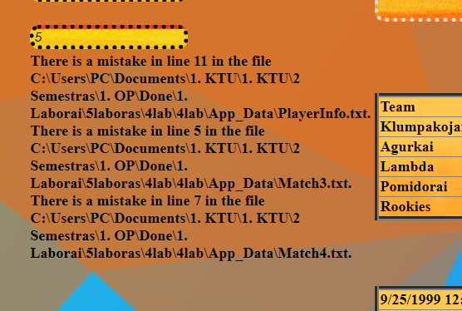

## Dėstytojo pastabos

Testo rezultatas: 0